Foundation 2 Weekly Timetable Week Commencing 28.11.22
To contact your child’s class teacher, please email schooloffice@dawpool.wirral.sch.uk or phone 0151 648 3412
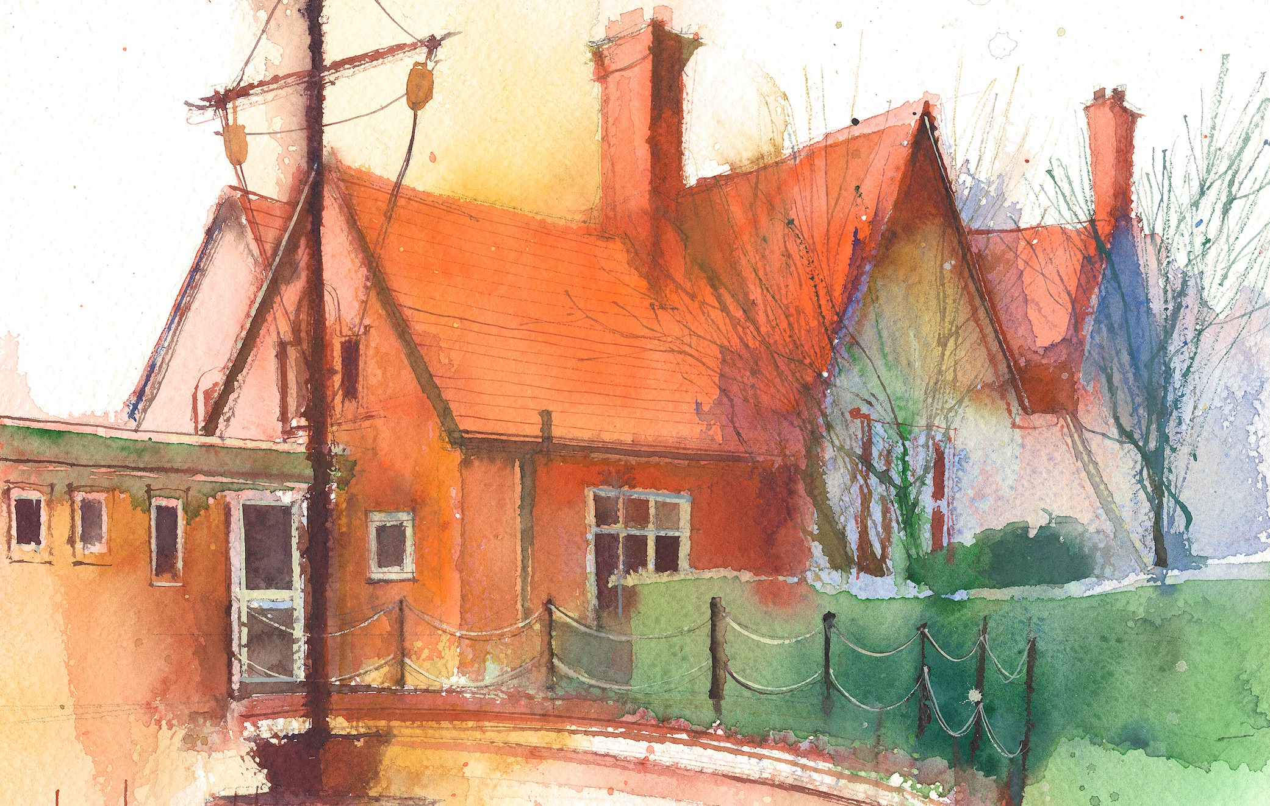

This timetable is available in the event that a Foundation 2 pupil is required to self-isolate at home, but the cohort remains open to other pupils.
Please visit the Foundation 2 Remote Learning Page on the school website to access any downloadable resources and activity sheets.

 | Session 1: 09:00-10:30 |  | Session 2: 10:50 – 12:00 |  | Session 3: 13:15 – 15:25
Monday  28/11/22 | Phonics  By the end of this lesson your child should be able to:  Recognise and say the sound ‘f and ff’  We recommend the following resources and activities to achieve this objective:  Blending practice.  Children will complete activities in their individual rocket phonics workbooks.  (Week 10) |  | Maths  By the end of this lesson your child should be able to:  To be able to recognise and name shapes and their properties  We recommend the following resources and activities to achieve this objective:  Play ‘What’s in the bag’.  I will put my hand in a bag and describe the properties of a shape, can they name it?  “It has 4 sides and 4 corners, what could it be?” Is that the only shape it could be? Are there any other shapes with 4 sides and 4 corners? Discuss the difference between a square and a rectangle.  Continue the game for circle, oval, triangle, square, rectangle, pentagon and star. |  | Topic  During the afternoons we will undertake activities linked to all areas of the Early Years Curriculum;  Prime Areas; Communication and Language;  Personal, Social and Emotional Development;  Physical Development.  Specific Areas; Literacy, Maths, Understanding the World and Expressive Arts and Design.  Afternoon sessions will also include RE, HeartSmart and Forest Schools.  Activities will be linked to our class topic which is ‘Where in the World’. We aim to use children’s films as a hook for learning to help us find out more about the world around us. Throughout the year we will select films that enable us to cover all requirements of the Early Years Curriculum.  We will talk about where the film is set and find out where this country is on a map. We will then the theme of the film as a way of guiding our planning.  PLEASE NOTE  The very nature of the EYFS curriculum enables us to go with the interests of the children. The activities we plan are for a guide only.  Staff can use and adapt activities or add additional activities and not cover others. It is all dependent on how and where the children’s interests take us.  Activities are designed to cover several weeks, if needed.  A copy of the current topic plan is available to view on the class website page.
Tuesday  29/11/22 | Phonics  By the end of this lesson your child should be able to:  Recognise and write the sound ‘f and ff’  We recommend the following resources and activities to achieve this objective:  Segmenting practice.  Children will complete activities in their individual rocket phonics workbooks. |  | Maths  By the end of this lesson your child should be able to:  Select, rotate and manipulate shapes to develop spatial reasoning.  We recommend the following resources and activities to achieve this objective:  Show a selection of different sized circles, triangles and squares. We need to put them in order, starting with the smallest.  Work together in small groups to order different sized shapes. Have they ordered them correctly? How do they know?  Talk about small, smaller, smallest/big, bigger, biggest.
Wednesday  30/11/22 | Phonics  By the end of this lesson your child should be able to:  Recognise and say the sound ‘l’  We recommend the following resources and activities to achieve this objective:  Blending practice  Children will complete activities in their individual rocket phonics workbooks. |  | Maths  By the end of this lesson your child should be able to:  To develop a basic understanding of time.  We recommend the following resources and activities to achieve this objective:  Show the yellow teaching clock. Explain that when the big hand is pointing at the twelve it tells us it is “o’clock”. When the little hand is pointing at a number it tells us what time it is.  Demonstrate 1 o’clock and talk about things they may be doing at 1 o’clock in the day and night.  Move the hands and talk about time passing. Show 2, 3 etc. Can they say what time it is as we move the hands around.  Talk about things they might be doing at that time of the day and act them out.
Thursday  01/12/22 | Phonics  By the end of this lesson your child should be able to:  Recognise and write the sound ‘l’  We recommend the following resources and activities to achieve this objective:  Segmenting practice  Children will complete activities in their individual rocket phonics workbooks. |  | Maths  By the end of this lesson your child should be able to:  To develop a basic understanding of time.  We recommend the following resources and activities to achieve this objective:  Show the 1 minute sand timer. Explain that this timer lasts for 1 minute which is 60 seconds. Is 60 seconds a long time?  What things can you do in 60 second? Using the 60 second countdown on YouTube, complete some challenges. Star jumps/the plank/jog on the spot. Can they take their shoes off and put them back on? How many times can they write their name in 1 minute?  Keep talking about time and saying 1 minute is 60 seconds whilst doing the activities.
Friday  02/12/22 | PE  By the end of this lesson your child should be able to:  Revise and refine fundamental movement skills already acquired.  We recommend the following resources and activities to achieve this objective:  During this half term the children will use the hall space to undertake games and activities that require them to roll, crawl, walk, jump, run, hop, skip and climb.  Children will also learn to stop and change directions safely. |  | Phonics  By the end of this lesson your child should be able to:  To consolidate learning of the sounds satipnmdgockeurhb and CEW ‘I, the, to, go, no, into’.  To practice writing the CEW ‘go’  We recommend the following resources and activities to achieve this objective:  Children will complete activities in their individual rocket phonics workbooks.

