Foundation 2 Weekly Timetable Week Commencing 18.5.26
To contact your child’s class teacher, please email schooloffice@dawpool.wirral.sch.uk or phone 0151 648 3412
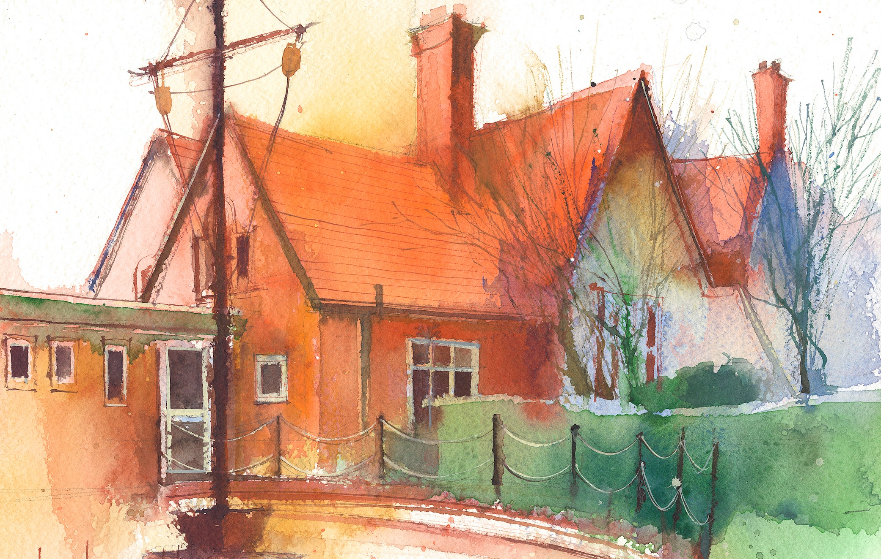

This timetable is available in the event that a Foundation 2 pupil is required to self-isolate at home, but the cohort remains open to other pupils.
Please visit the Foundation 2 Remote Learning Page on the school website to access any downloadable resources and activity sheets.

 | Session 1: 09:00-10:30 | Session 2: 10:50 – 12:00 | Session 3: 10:50 – 12:00 | Session 4: 10:50 – 12:00
Monday | Literacy  Adult Led Focus  Read the section where the boy climbs up the mountain and uses the rope to get up to the moon. They fix the engine together.  Can he really get back up to the moon this way?  PP to discuss.  I will then tell them a sentence I have to match the image. Can they could the words in my sentences and help me write it?  “He had to go up the hill.”  Look together at how many CEW are in the sentence. How many digraphs? | Phonics  By the end of this lesson your child should be able to:  To learn to read and recognise the digraph ‘er’  We recommend the following resources and activities to achieve this objective:  Blending practice.  Children will complete activities in their individual rocket phonics workbooks. | Maths  By the end of this lesson your child should be able to:  To explore and identify odd and even numbers through sharing and pairing.  We recommend the following resources and activities to achieve this objective: Have a selection of socks on the carpet. Physically match items into twos. “Does everything have a partner?”  “Is anything left on its own?”  Repeat the activity but remove one of the socks so pairs can’t be made.  Introduce language:  Even = all paired up together.  Odd = one left over | Topic  Aliens  Can they create their own aliens?  Encourage children to describe the aliens, thinking about what they look like and what characteristics they might have. PP work to share ideas  Write a list of features the aliens might have, different colours, patterns, number of arms, legs, eyes.  How do they move? Can they fly, jump, bounce, dance?  Draw their alien and write captions to describe it.
Tuesday | Literacy  Adult Led Focus  Read the section of the story where the boy and alien both fly home, in different directions.  What do you think they should say to each other when the plane and spaceship are fixed?  PP to discuss sentences.  I will model writing one of their sentence on the board. | Phonics  By the end of this lesson your child should be able to:  The learn to write the digraph ‘er’  We recommend the following resources and activities to achieve this objective:  Segmenting practice.  Children will complete activities in their individual rocket phonics workbooks. | Maths  By the end of this lesson your child should be able to:  To explore and identify odd and even numbers through sharing and pairing.  We recommend the following resources and activities to achieve this objective: Ask all the children to move around the room. When the bell rings can they get into pairs? If it is an odd number of children use an adult to ensure pairs can be made. Explain we can make pairs because it is Even = all paired up together.  Now repeat the activity with an odd number of people. Explain that pairs can’t be made because it is Odd = one left over Explain that even numbers can be shared equally into two groups. Odd numbers can’t be shared equally. | Topic  Design an Alien  Show the children some pictures of ‘aliens’ (selfies I’ve taken on the i-pad).  Talk about how I might have created these pictures. Explain that today they will be taking their own alien pictures ready to write a sentence about them.  Split into groups to work on the i-pads.  Show the children which app we need ‘Photo Booth’ and allow them to explore the features for themselves for a while.  Print off pictures and get the children to write a caption or sentence about their character.
Wednesday | Literacy  Adult Led Focus  Look at the final pages of the story – there are no words for me to read?  What should I do?  PP to share ideas?  How do we know what is happening?  Share story ideas.  I will write some of their sentences to match the section of the story. | Phonics  By the end of this lesson your child should be able to:  The consolidate the digraphs ar, or  We recommend the following resources and activities to achieve this objective:  Blending practice  Children will complete activities in their individual rocket phonics workbooks. | Maths  By the end of this lesson your child should be able to:  To explore and identify odd and even numbers through sharing and pairing.  We recommend the following resources and activities to achieve this objective: Have two hoops on the carpet labelled ‘odd’ and ‘even’.  Have number tiles 1,2,3,4,5,6 on the carpet. Can they put the tiles into the correct hoops? “How do you know?” “Can you prove it?” “Could the cubes help us?”  Add cubes to each of the number tiles. Can the numbers be split equally? Is there one left over?  If they are split equally into two groups they will be even. If they can’t be split equally they will be odd. | PE  By the end of this lesson your child should be able to:  The focus of the learning is to bring together the suggested sequence of learning into mini games.  Pupils will apply their understanding of attacking (fish) and defending (sharks), applying it into a competitive game.  We recommend the following resources and activities to achieve this objective:  Sharks V Fishes  Split the class into teams of 5 (use bibs to distinguish each team). Teams take turns to be the sharks. The sharks have 5 attempts to catch as many fishes as possible. Each time a shark catches an attacker they score a point.  When sharks score a point they can place an object (cone or beanbag) into their team's hoop to record their score. Once both teams have had a turn at being the sharks, the team with the most points are the winners
Thursday | Literacy  Adult Led Focus  Re-cap on the story and add an action to key parts.  Look at the story map images.  In PP think of a sentence to add to each part of the story.  I will model writing these on the board. | Phonics  By the end of this lesson your child should be able to:  To consolidate the learning of the digraphs ur, ow  We recommend the following resources and activities to achieve this objective:  Segmenting practice  Children will complete activities in their individual rocket phonics | Maths  By the end of this lesson your child should be able to: To explore and identify odd and even numbers through sharing and pairing.  We recommend the following resources and activities to achieve this objective: Can the children recognise a pattern in odd and even numbers.  Show a large number line with colours on it  Even = one colour  Odd = another  Discuss the pattern of alternate numbers.  “What pattern can you see?”  “What do you think comes next?” | RE  By the end of this lesson your child should be able to:  Why do some people of faith remove their shoes before entering a place of worship?  We recommend the following resources and activities to achieve this objective:  Members of a Hindu Mandir remove their shoes when they enter the building to worship.  Use a Google image search to find pictures of Hindu Temples worldwide.  Kanchipuram Temples – South India  Sri Ranganathaswamy Temple – India  Prambanan – Indonesia  Angkor Wat – Cambodia  Oldham Temple – UK  Visitors to these places must also take off their shoes. Why?  What are the differences between the Mandir, Churches, and Mosques?  What would be the same in each of these places of worship and what would be different? Record in your floor book  Generally, across all World Faiths, the removal of shoes when entering a place of worship is due to instruction in the scriptures, respect, humility, feeling at home and for reasons of cleanliness.
Friday | Literacy  Adult Led Focus  Re-cap on the story. Using thumbs ask if they liked the story yes, no, maybe.  I PP discuss together what they liked the best.  Explain that a book review is something that helps other people know about new books and shares things that are good about a book with them.  I will model a sentence. “This is a good book. It is fun.” | Phonics  By the end of this lesson your child should be able to:  To learn to read and write the Common Exception words out, like  We recommend the following resources and activities to achieve this objective:  Children will complete activities in their individual rocket phonics workbooks. | Maths  By the end of this lesson your child should be able to: To explore and identify odd and even numbers through sharing and pairing.  .We recommend the following resources and activities to achieve this objective:  Explain we are going to be challenged to decide “is it is odd or is it even?”  Use the jumbo dice and a selection of cubes.  Roll the dice. Is the number odd or even? How do we know? How could we demonstrate it? | Heart Smart  By the end of this lesson your child should be able to:  Tell others something special about our home and families.  We recommend the following resources and activities:  Ask the children to select one thing from the classroom that they like or enjoy playing with.  Children to take it in turns sharing the object they have chosen and why.  Encourage the other children to listen when the child at the front is speaking and to think of a question they can ask about the child’s item .  After the children have all shared their items talk about how wonderful it is that so many different items were shared Explain that if all the children had chosen the same item in it would have been very boring. Tell the children that their items are all different because they are all different. The things that make us different make the class a more interesting and special place to be.  Be sure to emphasise that just as everyone is different, everyone is also important.

