Dawpool C.E. (Aided)
Primary School

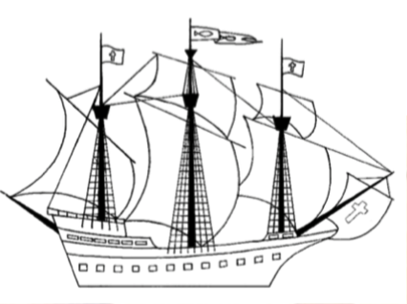
DAWPOOL
Year 4 Curriculum

Wisdom, Knowledge and Skills
‘The Fruit of the Spirit is Love, Joy, Peace, Patience, Kindness, Generosity, Faithfulness, Gentleness and Self-Control’ (Galatians 5: 22-23).

Vision Statement
‘The Dawpool community are united in their ambition to create a school which embodies the person, love and work of Jesus Christ: a school which enables Christian values to flourish and where all children may experience the abundant life that Jesus offers.’

Dawpool C.E (Aided) Primary School
School Lane
Thurstaston
Wirral
CH61 0HH

0151 648 3412
schooloffice@dawpool.wirral.sch.uk
www.dawpool-ce.eschools.co.uk
@DawpoolCofE
1
The Dawpool ‘Curriculum for Christ-Likeness’ 4
Year 4 Curriculum Topics 8
Year 4 Enrichment 8
Year 4 Reading Spine 8
A Year 4 Reader at Dawpool 9
Word Reading 9
Comprehension 9
Greater Depth in Reading 10
A Year 4 Writer at Dawpool 10
Transcription 10
Composition 11
Year 3/4 Statutory Spelling List 12
Vocabulary, Grammar and Punctuation 13
Greater Depth in Writing 14
A Year 4 Speaker at Dawpool 14
Greater Depth in Speaking 14
A Year 4 Mathematician at Dawpool 15
Number, place value, approximation and estimation/rounding 15
Calculations 15
Fractions, decimals and percentages 16
Measurement 16
Geometry – properties of shapes 17
Statistics 17
Greater Depth in Mathematics 17
A Year 4 Scientist at Dawpool 18
Working scientifically 18
Biology 18
Chemistry 19
Physics 19
Greater Depth in Science 20
Year 4 Scientific Vocabulary 20
A Year 4 Historian at Dawpool 21
The Romans 21
The Empire and its impact on Britain (Boudicca) 21
Year 4 Historical Vocabulary 22
A Year 4 Geographer at Dawpool 22
Volcanoes and Earthquakes 22
Liverpool 23
The River Mersey 23
Year 4 Geographical Vocabulary 23
A Year 4 Theologian at Dawpool 24
Year 4 Theological Vocabulary 27
A Year 4 Artist at Dawpool 28
Volcanoes and Earthquakes: Hokusai-pastels 28
Romans study of colour pattern 28
Investigating Pattern 28
Year 4 Art Vocabulary 28
A Year 4 Designer at Dawpool 28
Seasonal Food 28
Greenhouses 29
Storybooks 29
Year 4 Design Vocabulary 29
A Year 4 Computer User at Dawpool 30
Algorithms and programming 30
Information technology 30
Digital literacy 30
A Year 4 Safe Computer User at Dawpool 30
Knowledge and understanding 30
Skills 31
Year 4 Computing Vocabulary 31
A Year 4 Musician at Dawpool 32
Year 4 Music Vocabulary 32
A Year 4 International Speaker at Dawpool 32
Year 4 French Vocabulary (Topic Headings) 33
A Year 4 Sports Person at Dawpool 33
Games 33
Gymnastics 34
Dance 34
Athletics 34
Outdoor and adventurous 34
Year 4 PE Vocabulary 34

The Dawpool ‘Curriculum for Christ-Likeness’

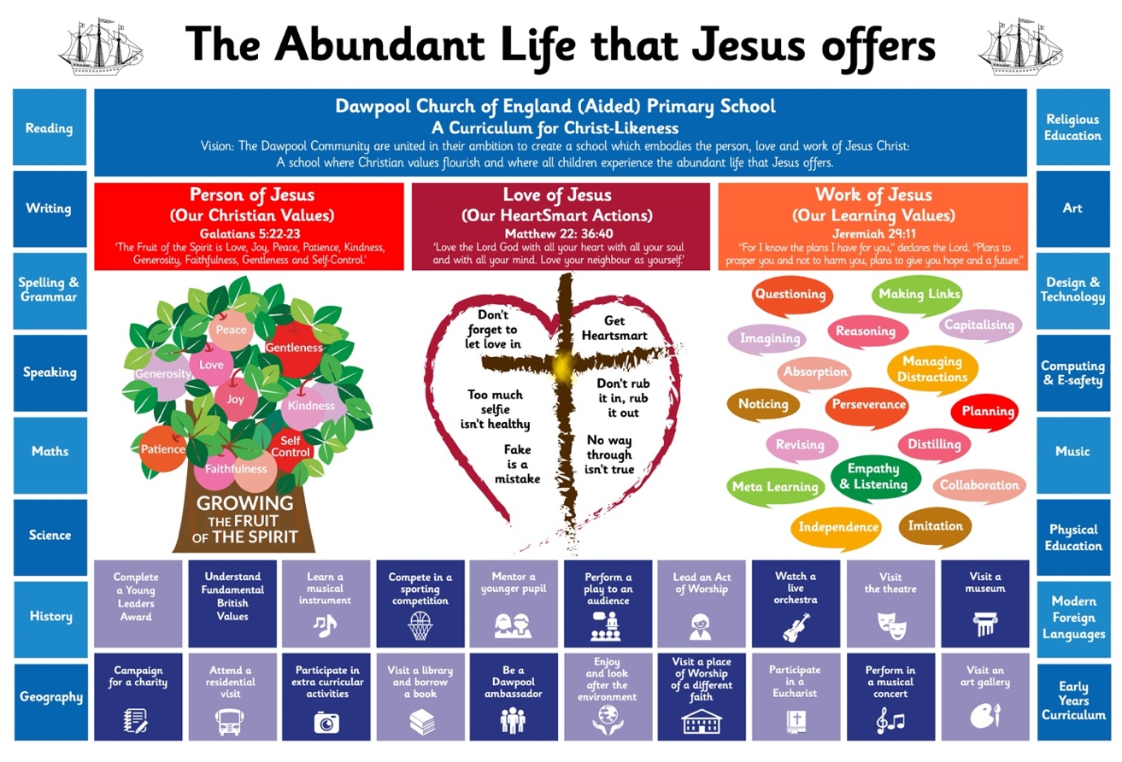

Vision Statement
‘The Dawpool community are united in their ambition to create a school which embodies the person, love and work of Jesus Christ: a school which enables Christian values to flourish and where all children may experience the abundant life that Jesus offers.’

The Dawpool curriculum is designed to:
- Embody the 'Person, Love and Work' of Jesus Christ.
- Enable 'Christian Values to Flourish'.
- Ensure that all pupils experience the ‘Abundant Life that Jesus offers.’

These three overarching objectives relate directly to the core principles of our vision statement.
The Person, Love and Work of Jesus are three golden threads that run through the heart of our curriculum
At Dawpool, we aim to embody the person of Jesus Christ by growing the Fruit of the Spirit. | At Dawpool, we aim to we embody the love of Jesus Christ by teaching pupils to be HeartSmart. | At Dawpool we aim to embody the work of Jesus Christ by teaching pupils core learning values.

We know that all of these values were demonstrated by Jesus in his life. They are also rooted in pedagogy, such as Guy Claxton’s ‘Building Learning Powers’ and Rosenshine’s ‘Principles of Instruction.’
In our curriculum planning we have taken each individual value - whether it be a Fruit of the Spirit, a HeartSmart action or a Learning Value - and directly referenced each one to the example of Jesus by providing a definition of the value, linking it to scripture and providing specific examples of how Jesus demonstrated it – see The Curriculum for Christ-Likeness. By teaching the children how to emulate these values we enable Christian values to flourish through our curriculum.
Dawpool’s focus on developing Christian and learning values through the curriculum encourages children to stretch themselves spiritually, morally, intellectually, imaginatively and actively. The impact of Dawpool’s Curriculum for Christ-Likeness is that pupils are curious, confident and resilient learners who develop a sense of character and enjoy their learning. The Dawpool Curriculum places emphasis on character development and wider flourishing, recognising that these are fundamental to any sustained academic success.
The image below provides an overview of what the Person, Love and Work of Jesus looks like at a classroom level. Whether it be a Science lesson or a History lesson, there are familiar characteristics of effective learning:
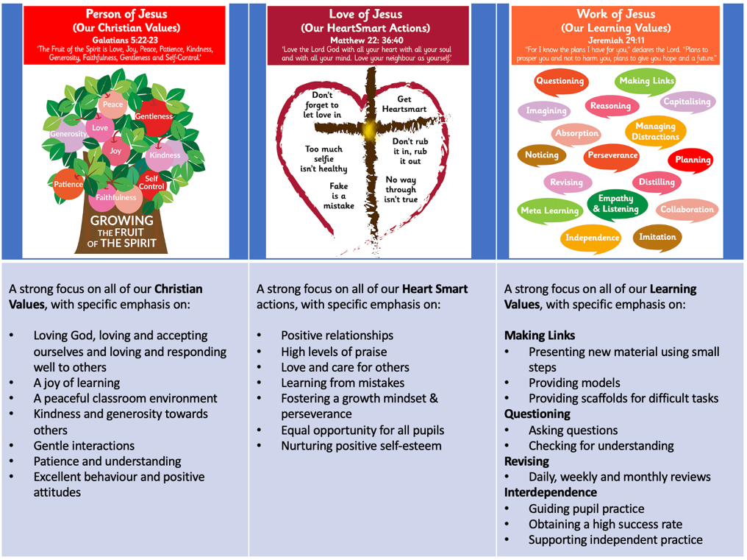
Jesus’ greatest commandment (Matthew 22:36-40) is central to the life of Dawpool: Loving God, loving and accepting ourselves and loving and responding well to others.
The next part of our curriculum is to ensure that all pupils experience the ‘Abundant Life that Jesus Offers’. This is defined as enabling all children to experience the full curriculum – it’s not narrowed for any child. We aim to nurture children’s God-given talents and provide for their intellectual, emotional, personal, social, spiritual and physical development.
We provide a subject-specific curriculum in which we have mapped out the knowledge and skills that we want children to learn at each stage (See the ‘Wisdom, Knowledge and Skills’ documents for each year group and the subject specific documents).

The Subject Specific Curriculum
For each subject, we have carefully established the expectations for timetabling, planning, marking and assessment to ensure that the curriculum is delivered fully to all pupils – see the Curriculum Implementation Handbook.
Where possible, subjects are delivered through topics which are designed for maximum engagement and ensure all pupils benefit from a rich, broad, balanced curriculum presented in an interesting, exciting and imaginative manner with lots of opportunities for first-hand experience, practical work, investigation and learning through play. The curriculum is enriched with visits, visitors, and extensive use of our unique environment.
Our ‘local curriculum’ provides for an informal programme of enrichment and extra-curricular activities which is made up of those activities that we feel all children should experience at least once during their time in school, but in reality, there is likely to be several opportunities for each child. Such activities include: completing a young leaders award, learning a musical instrument, mentoring a younger pupil and leading an Act of Worship.

The Local Curriculum

Therefore, Dawpool’s full curriculum incorporates the Person, Love and Work of Jesus as three golden threads running through the curriculum with Jesus’ greatest commandment at its heart. it includes our subject-specific curriculum and our local curriculum of enrichment and extra-curricular activities.

Year 4 Curriculum Topics

Where appropriate, the vocabulary, knowledge and skills for Year 4 are delivered through the following broad topics:

 | Autumn | Spring | Summer
Y4 | Volcanoes | Romans | Liverpool

Year 4 Enrichment

Year 4 Reading Spine

English Curriculum | Reading for Pleasure | No Outsiders
The Iron Man  Jemmy Button  The Remarkable Journey of Edward Tulane  Bright Bursts of Colour (Poetry) | Archaic: The Little Match Girl, Hans Christian Anderson  Non-Linear: The Midnight Fox  Complexity of the Narrator: Woof, Allan Ahlberg  Complexity of Plot/Symbol: Ducks Ditty (poem)  Resistant Text: The Mysteries of Harris Burdick, Chris Van Allsburg (picture book) | Along Came a Different  Dogs Don’t Do Ballet  Red, A Crayon’s Story  Aalfred and Aalbert  When Sadness Comes to Call  Julian is a Mermaid

A Year 4 Reader at Dawpool

Word Reading

- I can apply my knowledge of root words, prefixes and suffixes to read aloud and to understand the meaning of unfamiliar words.
- I can read further exception words, noting the unusual correspondences between spelling and sound.
- I attempt pronunciation of unfamiliar words drawing on prior knowledge of similar looking words.

Comprehension

- I know which books to select for specific purposes, especially in relation to science, geography and history learning.
- I can use a dictionary to check the meaning of unfamiliar words.
- I can discuss and record words and phrases that writers use to engage and impact on the reader.
- I can identify some of the literary conventions in different texts.
- I can identify the (simple) themes in texts.
- I can prepare poems to read aloud and to perform, showing understanding through intonation, tone, volume and action.
- I can explain the meaning of words in context.
- I can ask relevant questions to improve my understanding of a text.
- I can infer meanings and begin to justify them with evidence from the text.
- I can predict what might happen from details stated and from the information I have deduced.
- I can identify where a writer has used precise word choices for effect to impact on the reader.
- I can identify some text type organisational features, for example, narrative, explanation and persuasion.
- I can retrieve information from non-fiction texts.
- I can build on others’ ideas and opinions about a text in discussion.

Greater Depth in Reading

- I can locate and use information from a range of sources, both fiction and non-fiction.
- I can compare fictional accounts in historical novels with the factual account.
- I can appreciate the bias in persuasive writing, including articles and advertisements.
- I can talk widely about different authors, giving some information about their backgrounds and the type of literature they produce.
- I can use inference and deduction to work out the characteristics of different people from a story.
- I can compare the language in older texts with modern Standard English (spelling, punctuation and vocabulary).
- I can skim, scan and organise non-fiction information under different headings.
- I can refer to the text to support my predictions and opinions.
- I can recognise complex sentences.
- I can show awareness of the listener through the use of pauses, giving emphasis and keeping up an appropriate pace so as to entertain and maintain interest.

A Year 4 Writer at Dawpool

Transcription

Spelling

- I can spell words with prefixes and suffixes and can add them to root words.
- I can recognise and spell homophones.
- I can use the first two or three letters of a word to check a spelling in a dictionary.
- I can spell the commonly mis-spelt words from the Y3/4 word list.

Handwriting

- I can use the diagonal and horizontal strokes that are needed to join letters.
- I understand which letters should be left unjoined.
- My handwriting is legible and consistent; down strokes of letters are parallel and equidistant; lines of writing are spaced sufficiently so that ascenders and descenders of letters do not touch.

Composition

- I can compose sentences using a range of sentence structures.
- I can orally rehearse a sentence or a sequence of sentences.
- I can write a narrative with a clear structure, setting and plot.
- I can improve my writing by changing grammar and vocabulary to improve consistency.
- I use a range of sentences which have more than one clause.
- I can use appropriate nouns and pronouns within and across sentences to support cohesion and avoid repetition.
- I can use direct speech in my writing and punctuate it correctly.

Year 3/4 Statutory Spelling List

Vocabulary, Grammar and Punctuation

Word

- I know the grammatical difference between plural and possessive –s
- I know the standard English forms for verb inflections instead of local spoken forms [for example, we were instead of we was, or I did instead of I done]

Sentence

- I can expand noun phrases by the addition of modifying adjectives, nouns and preposition phrases (e.g. the teacher expanded to: the strict maths teacher with curly hair)
- I can use Fronted adverbials [for example, Later that day, I heard the bad news.]

Text

- I can use of paragraphs to organise my ideas around a theme
- I can appropriately choose either pronoun or noun within and across sentences to aid cohesion and avoid repetition

Punctuation

- I can use of inverted commas and other punctuation to indicate direct speech [for example, a comma after the reporting clause; end punctuation within inverted commas: The conductor shouted, “Sit down!”]
- I can use apostrophes to mark plural possession [for example, the girl’s name, the girls’ names]
- I can use commas after fronted adverbials

Terminology

- Determiner, pronoun, possessive pronoun, adverbial

Greater Depth in Writing

- I am prepared to carry out some research to find words that are particular to the event being written about.
- I can check to see if there are any sentences that can be re-organised so as to give my writing a greater impact.
- I can deliberately use short sentences to speed up action sequences.
- I can use dialogue and reactions from other characters to make my character interesting.
- I can recognise when a simile may generate more impact than a metaphor, and vice versa.
- I can recognise when it is reasonable to allow direct speech to tell the reader more about an individual’s personality.
- I can recognise that a combination of good adjectives, similes and metaphors may help create a powerful image of the characters I am writing about.
- I know how to re-order sentences so that they create maximum effect.
- I can vary my choice of pronouns correctly to refer to the first, second and third person, both singular and plural.
- I can use commas or ellipses in order to create greater clarity and effect in my writing.

A Year 4 Speaker at Dawpool

- I ask questions to clarify or develop my understanding.
- I can sequence, develop and communicate ideas in an organised and logical way, always using complete sentences.
- I show that I understand the main point and the details in a discussion.
- I adapt what I am saying to the needs of the listener or audience (increasingly).
- I show that I know that language choices vary in different contexts.
- I can present to an audience using appropriate intonation; controlling the tone and volume so that the meaning is clear.
- I can justify an answer by giving evidence.
- I use Standard English when it is required.
- I can perform poems or plays from memory, conveying ideas about characters and situations by adapting expression and tone.

Greater Depth in Speaking

- I can prepare and deliver a talk to the class on an aspect of learning in science, history or geography.
- I can present a strong argument in a formal debate on an issue, using the language and procedures of debating.
- I can propose and discuss possible explanations and questions (e.g. re phenomena in science, history or geography) as a basis for planning an investigation with roles, activities and resources.
- I can develop a group presentation that reports recent learning to the class, with vocabulary and grammar appropriate to the subject.
- I can listen to a debate with an open mind, recall the main arguments and decide, for clear reasons, which one was most convincing.
- I can comment on the language used in the arguments presented in a debate.
- I can take roles to argue opposing views on an issue, and then discuss ways of dealing constructively with disagreement.
- I can reflect on and evaluate my dramatic presentations and those of others.
- I can explain the advantages and disadvantages of the formal rules of debating.
- I show a good understanding of what has been said and can introduce new ideas that are valid.

A Year 4 Mathematician at Dawpool

Number, place value, approximation and estimation/rounding

- I can count in multiples of 6, 7, 9, 25 and 1,000.
- I can order and compare numbers beyond 1,000.
- I can find 1,000 more or less than a given number.
- I recognise the place value of each digit in a 4-digit number.
- I can read Roman numerals to 100 and know that over time the numeral system changed to include the concept of zero and place value.
- I can identify, represent and estimate numbers using different representations.
- I can round any number to the nearest 10, 100 or 1,000.
- I can count backwards through zero to include negative numbers.
- I can solve number and practical problems with the above (involving increasingly large numbers).

Calculations

- I can add and subtract numbers with up to 4-digits using the formal written methods of columnar addition and subtraction.
- I can estimate and use inverse operations to check answers in a calculation.
- I can solve addition and subtraction 2-step problems in contexts, deciding which operations and methods to use and why.
- I an recall multiplication and division facts up to 12x12.
- I can use place value, known and derived facts to multiply and divide mentally, including: multiplying by 0 and 1; dividing by 1; multiplying together three numbers.
- I recognise and use factor pairs and commutativity in mental calculations.
- I can multiply 2-digit numbers by a 1-digit number using formal written layout.
- I can solve problems involving multiplying and adding, including using the distributive law to multiply 2-digit numbers by 1-digit, integer scaling problems and harder correspondence problems such as n objects are connected to m objects.

Fractions, decimals and percentages

- I an count up and down in hundredths.
- I recognise that hundredths arise when dividing an object by a hundred and dividing tenths by ten.
- I recognise and show using diagrams, families of common equivalent fractions.
- I can add and subtract factions within the same denominator.
- I recognise and write decimal equivalents to 1/4, 1/2 and ¾.
- I recognise and write decimal equivalents of any number of tenths or hundredths.
- I can round decimals with one decimal place to the nearest whole number.
- I can compare numbers with the same number of decimal places up to 2 decimal places.
- I can find the effect of dividing a 1-digit or 2-digit number by 10 and 100, identifying the value of the digits in the answer as ones, tenths and hundredths.
- I can solve problems involving increasingly harder factions and fractions to divide quantities, including non-unit fractions where the answer is a whole number.
- I can solve simple measure and money problems involving fractions and decimals to 2 decimal places.

Measurement

- I can compare different measures, including money in £ and p.
- I can estimate different measures, including money in £ and p.
- I can calculate different measures. Including money in £ and p.
- I can read, write and convert time between analogue and digital 12 hour clocks.
- I can read, write and convert time between analogue and digital 24 hour clocks.
- I can solve problems involving converting from hours to minutes; minutes to seconds; years to months; weeks to days.
- I can convert between different units of measurements
- I can measure and calculate the perimeter of a rectilinear figure in cm and m.
- I can find the area of rectilinear shapes by counting squares.
- I can calculate different measures.

Geometry – properties of shapes

- I can compare and classify geometric shapes, including quadrilateral and triangles based on their properties and sizes.
- I can identify lines of symmetry in 2D shapes presented in different orientations.
- I can complete a simple symmetric figure with respect to a specific line of symmetry,
- I can identify acute and obtuse angles and compare and order angles up to two right angles by size.
- Geometry – position and direction
- I can describe movements between positions as translations of a given unit to the left/right and up/down.
- I can describe positions on a 2D grid as coordinates in the first quadrant.
- I can plot specified points and draw sides to complete a given polygon.

Statistics

- I can interpret and present discrete and continuous data using appropriate graphical methods, including bar charts and time graphs.
- I can solve comparison, sum and difference problems using information presented in bar charts, pictograms, tables and other graphs.

Greater Depth in Mathematics

- I can use tenths, hundredths and thousandths when comparing values and solving addition and subtraction problems.
- I can round any number to 100,000 to the nearest 10, 100, 1,000 or 10,000.
- I can relate tenths and hundredths to fractional values.
- I can rapidly recall answer when multiplying and dividing a whole or decimal number by 10.
- I can solve multi-step problems involving more than one of the operations.
- I can work out simple percentage values of whole numbers, for example, as met in on-going learning in science, history and geography .
- I can compare and add fractions whose denominators are all multiples of the same number.
- I can use a 24-hour timetable to find out times for journeys between various places.
- I can use my knowledge of perimeter to work out the perimeter of large areas around school, using metres and centimetres.
- I can collect my own data on a given project and present information in graphical formats of my choosing.

A Year 4 Scientist at Dawpool

Working scientifically

- I can ask relevant scientific questions.
- I can use observations and knowledge to answer scientific questions.
- I can set up a simple enquiry to explore a scientific question.
- I can set up a test to compare two things.
- I can set up a fair test and explain why it is fair.
- I can make careful and accurate observations, including the use of standard units.
- I can use equipment, including thermometers and data loggers to make measurements.
- I can gather, record, classify and present data in different ways to answer scientific questions.
- I can use diagrams, keys, bar charts and tables; using scientific language.
- I can use findings to report in different ways, including oral and written explanations, presentation.
- I can draw conclusions and suggest improvements.
- I an make a prediction with a reason.
- I can identify differences, similarities and changes related to an enquiry.

Biology

Living things and their habitats
- I can group living things in different ways.
- I can use classification keys to group, identify and name living things.
- I can create classification keys to group, identify and name living things (for others to use).
- I can describe how changes to an environment could endanger living things.

Animals, including humans
- I can identify and name the parts of the human digestive system.
- I can describe the functions of the organs in the human digestive system.
- I can identify and describe the different types of teeth in humans.
- I can describe the functions of different human teeth.
- I can use food chains to identify producers, predators and prey.
- I can construct food chains to identify producers, predators and prey.

Chemistry

States of matter
- I can group materials based on their state of matter (solid, liquid, gas).
- I can describe how some materials can change state.
- I can explore how materials change state.
- I can measure the temperature at which materials change state.
- I can describe the water cycle.
- I can explain the part played by evaporation and condensation in the water cycle.

Physics

Electricity
- I can identify and name appliances that require electricity to function.
- I can construct a series circuit.
- I can identify and name the components in a series circuit (including cells, wires, bulbs, switches and buzzers).
- I can draw a circuit diagram.
- I can predict and test whether a lamp will light within a circuit.
- I can describe the function of a switch in a circuit.
- I can describe the difference between a conductor and insulators; giving examples of each.

Sound
- I can describe how sound is made.
- I can explain how sound travels from a source to our ears.
- I can explain the place of vibration in hearing.
- I can explore the correlation between pitch and the object producing a sound.
- I can explore the correlation between the volume of a sound and the strength of the vibrations that produced it.
- I can describe what happens to a sound as it travels away from its source.

Greater Depth in Science

- I can plan and carry out a scientific enquiry by controlling variables fairly and accurately.
- I can use test results to make further predictions and set up further comparative tests.
- I can record more complex data and results using scientific diagrams, classification keys, tables, bar charts, line graphs and models.
- I can report findings from scientific enquiries through written explanations and conclusions.
- I can explain how people, weather and the environment can affect living things.
- I can group and classify a variety of materials according to the impact of temperature upon them.
- I can relate temperature to the change of state of materials.
- I can work out which metals can be used to connect across a gap in a circuit.

Year 4 Scientific Vocabulary

moving | growing | teeth | skeleton
bones | organs | circulatory | system
lungs | heart | veins | oxygenated
oxygen | bacteria | canine | molar
premolar | wisdom | incisor | gum
decay | hygiene | blood | muscles
cells
circuit | open | closed | insulator
conductor | experiment | battery | motor
buzzer | wire | electricity | positive
negative
decibels | vibrate | conduct | travel
loud | quiet | sensor | ear
pitch | anvil | canal | echo
amplify | waves | deaf
solid | liquid | gas | matter
state | change | reversible | irreversible
soft | hard | flexible | mixture
heat | cool | transparent | translucent
opaque | metal | plastic | wood
burn | flame | air

A Year 4 Historian at Dawpool

All topics must begin with chronological knowledge, identifying the period of history on the corridor timeline.

The Romans

The Empire and its impact on Britain (Boudicca)
- I know how to find Rome on a map and show the position of Rome in context of Europe.
- I know when the Roman invasion of Britain took place and put key events on a timeline.
- I know the reasons the Romans invaded Britain.
- I know who resisted the Roman invasion and the consequences of this resistance.
- I know the effects of the Roman invasion on life in England.

- I can explain how the lives of wealthy people were different from the lives of poorer people.
- I can explain how historic items and artefacts can be used to help build up a picture of life in the past.
- I can explain some of the times when Britain has been invaded.
- I can explain how an event from the past has shaped our life today.
- I can research what it was like for children in a given period of history
- I can plot events on a timeline using centuries.
- I can use my mathematical skills to round up time differences into centuries and decades.
- I can research two versions of an event and explain how they differ.
- I can present my findings to an audience.
- I can describe a key event from Britain’s past using a range of evidence from different sources.

Year 4 Historical Vocabulary

Pantheon | Basilica | barbarian | chariot
slave | Villa | soldier | invasion
Caesar | dominate | legacy | democracy
numerals | mosaic | victory | Boudicca
Iceni | Tribe | defeat | centurion
Pompeii | Rome | capital | empire
gladiator | Sword | tunic | ampitheatre
myth

A Year 4 Geographer at Dawpool

All topics must begin with location knowledge:
Lower KS2 – The countries of Europe (including Russia)
Include human features: major cities, natural resources, settlement, trade, land use patterns and how these change over time etc.
Include physical features: rivers, lakes, mountains, coasts etc

Volcanoes and Earthquakes
- I know where are the main volcanoes and earthquakes located on a world map.
- I know when mount Vesuvius erupted.
- I know how volcanoes and earthquakes are created.
- I know the anatomy of a volcano.

Liverpool

The River Mersey
- I can place the key historical events of Liverpool on a timeline.
- I know how Liverpool affected the slave trade.
- I know some key famous historical figures born in Liverpool.
- I understand where to find Liverpool and other cities on a map of the U.K.
- I know that there are two cathedrals in Liverpool and understand how they represent different people.

- I can carry out research to discover features of villages, towns or cities.
- I can plan a journey to a place in England.
- I can collect and accurately measure information (e.g. rainfall, temperature, wind speed, noise levels etc).
- I can explain why people may be attracted to live in cities.
- I can explain why people may choose to live in one place rather than another.
- I can explain the difference between the British Isles, Great Britain and the United Kingdom.
- I can find at least six cities in the UK on a map.
- I can name and locate some of the main islands that surround the United Kingdom.
- I can name the areas of origin of the main ethnic groups in the United Kingdom and in our school.

Year 4 Geographical Vocabulary

ash | core | dormant | crust
extinct | eruption | lava | pumice
active | inactive | volcano | magma
mantle | pyroclastic | flow | tectonic
plate | collide | molten | Solid
liquid | gas | disaster | seismic
fire | ring | chamber | vent
explosion | mountain
industry | river | slave | trade
famous | visit | buildings | travel
exchange | money | rich | poor
attract | city | livelihood | import
immigrant | local | environment | mobile
slum | Population

A Year 4 Theologian at Dawpool

David and the Psalms
- I know key stories in the life of David and that David is a key figure in the Old Testament.
- I know that Christians believe that the nature of God is revealed in the psalms (King, shepherd, protector, great, rock, merciful and shield etc.)
- I can identify values that I think are important and connect values and Christian beliefs to events and teaching in the Bible.
- I can ask important questions about the stories of David that improve my learning.
Christmas
- I know that Christians believe that Jesus is the light of the world and that the light of Jesus brings hope in dark places.
- I know that Hannukah is a Jewish festival of light.
- I can tell stories about Jesus bringing light into people’s lives.
- I can talk about the lives of people who bring Jesus’ light into the world.
- I can tell you about the stories and traditions of Hanukkah.
- I can use good vocabulary to talk about the symbolism of Jesus as light.
- I can ask good questions about things that have interested me.
Jesus
- I know that Christians believe Jesus is the Son of God and that Jesus has power and authority over nature, sickness and death.
- I know the stories of people who have campaigned for justice.
- I know that the Jewish holy day is Shabbat.
- I can retell the Bible stories we have talked about and make links between the Bible stories and what Christians believe about Jesus.
- I can use religious language to show that I understand Jesus was both God and man.
- I can talk about why sometimes people speak out against authority for justice.
- I can tell you about what I have learnt and who has inspired me.
- I can talk, using religious language, about the traditions and meaning of Jewish Shabbat.
Easter
- I know that trust and forgiveness are key values in the teaching of World Faiths.
- I know that Christians believe that they can trust Jesus.
- I know that the events of Holy Week and Easter are key to understanding what Jesus came to earth to do.
- I know that the incidents of betrayal and trust in the Easter story are significant.
- I can identify and explain the significance of the incidents of betrayal and trust in the Easter story – God’s salvation plan.
- I can use key religious vocabulary to describe and talk about the importance of forgiveness in World Faiths and in my own life.
- I can ask good questions about people’s values and commitments.
- I can use religious vocabulary to make links between Christian beliefs and the stories of Palm Sunday, Holy Week and Easter.
- I can describe and show understanding of the Christian value of forgiveness in relation to the story of Peter.
- I can use religious vocabulary to make links between religious teaching and practices.
The Church
- I know that not all church buildings are the same but have similar features according to denomination.
- I know that Peter and the disciples ‘built’ the church after the events of Pentecost.
- I know that the Bible gives guidance to the church about behaviour and attitudes and I can talk about what that guidance is.
- I know that Christianity is a world-wide multi-cultural faith.
- I know world faiths have different places of worship and I can name the buildings, key features and the worship that takes place there.
- I know that the Hindu murtis (statues) are expressions of god and that they are not worshipped as they are a focus to enhance worship.
- I know that the symbol of light is used in several religions.
- I know that the features of the building can be connected to the Holy Scripture of that faith.
- I know the Imam is the leader of the Mosque and the Rabbi is the leader of the Synagogue.
- I can use religious vocabulary to name features of the church building, talk about their significance and links to the Bible and identify similarities and differences between churches and denominations worldwide.
- I can ask good questions about the similarities and differences between different denominational practices and make links between values and beliefs and behaviour.
- I can use the correct religious vocabulary to talk knowledgeably about places of worship, the features of the building and the worship that takes place there.
- I can identify the similarities and differences between the worship that takes place in a mosque and Hindu temple.
- I can identify the similarities and differences between the worship that takes place in a Hindu temple and a Sikh gurdwara.
- I can identify the similarities and differences between the worship that takes place in a synagogue and a mosque.
- I can make links between the places of worship I have explored and the beliefs of the worshipper.
- I can ask good questions to extend my knowledge and understanding.
- I can describe why light is used as a symbol for God in several religions.
- I can use religious language to talk about the symbols I have seen in the places of worship explored e.g. star of David, Aum and Swastika.
- I can describe the role of the Imam.
Prayer
- I know that prayer is a way of communicating with God.
- I know that prayer is an important part of the life of a believer and that prayer impacts on the daily life of a believer.
- I know that prayer can be very informal and private and that believers gather together to pray.
- I know that for some people of faith the direction in which they pray is important.
- I know that for some people of faith it is important to wash before you pray.
- I can talk using religious language about prayer in Christianity and in the world faiths studied.
- I can talk about my own experiences of prayer.
- I can identify the Christian beliefs revealed in the language of prayer.
- I can identify similarities and differences between the way believers pray across world faiths.
- I can identify artefacts used at times of prayer by people of faith.
- I can identify the beliefs of a Muslim/Hindu in the language of prayer

Year 4 Theological Vocabulary

Prophet | Samuel | David | Jonathan
Saul | Goliath | inspiration | Psalm
Jesus | light | candles | Christingle
Light of the World | Saviour and incarnation | Dreidel | Hanukkah
Hannukiah | Jerusalem | Temple | Son of God
authority | miracle | Sabbath/Shabbat | Pharisees
Trust | betrayal | forgiveness | Judas
loyalty | Peter | Gethsemane | Jerusalem
church | chapel | cathedral | sacrament
vicar | curate | priest | minister
worship | holy | sacred | Mosque
Minaret tower | Temple | Synagogue | Ark
Gurdwara | Langar | pray | prayer
collect

A Year 4 Artist at Dawpool

Key topics:

Iron Man-Tone, texture, movement and expression
- I can use marks and lines to show texture in my art.
- I can experiment to create a range of tones, experimenting to add dimension.
- I can show facial expressions and body language in sketches and paintings.
- I can use line, tone, shape and colour to represent figure and forms in movement.
- I can create my own sketch of a figure in movement.
- I can create a sketch of the Iron man using tone, line, shape and dimension.

Romans-investigating pattern
- I can explain some of the features from historical periods.
- I can create a stamp using Roman art work as my inspiration.
- I can create a pattern using a stamp I created.
- I can print onto different materials using 4 different colours.
- I can explore and continue patterns.
- I can create patterns using rotation and symmetry and reflection.
- I can create a pattern using a stencil(pressprint).

Andy Warhol and the Pop art movement
- I can find out who Andy Warhol was and explore the pop art movement.
- I can use Warhol’s blotted line technique to create artwork.
- I can explore and recreate Warhol’s Campbell’s soup art work.
- I can explore Warhol’s portraits of celebrities and create my own.
- I can create a self portrait in the style of Andy Warhol.
- I can use objectives of popular culture to create Pop art.
- I can explore an alternative Pop artist-Roy Lichtenstein.

- I can show facial expressions and body language in sketches and paintings.
- I can use marks and lines to show texture in my art.
- I can use line, tone, shape and colour to represent figure and forms in movement.
- I can show reflections in my art.
- I can print onto different materials using at least four colours.
- I can sculpt clay and other mouldable materials.
- I can integrate my digital images into my art.
- I can experiment with the styles used by other artists.
- I can explain some of the features of art from historical periods.

Year 4 Art Vocabulary

delicate | bold | contrasting | dramatic
subtle | rough | blending | smooth
uneven | stippling | repeating | vibrant
colourful | bright | dark | realistic
unrealistic | sketch | line | brush
Contour hatching | natural | unnatural | Shade
colour | reflecting | scumbling | Cross hatching

A Year 4 Designer at Dawpool

Seasonal Food
- I know how seasonal fruits and food are grown and processed.
- I can prepare food safely.
- I understand why vegetables form an important part of a healthy and varied diet.
- I can find out about how seasonally produced meat can form part of a healthy diet.
- I know how fish are caught or reared, processed and used in healthy meals.
- I can weigh ingredients accurately.
- I can prepare food safely and hygienicly.

Story books
- I can investigate and evaluate products with lever and linkage systems.
- I can experiment with a range of techniques to create moving mechanisms.
- I can explore and experiment with a range of different fonts and graphic tecniques.
- I can plan and design a story book with moving mechanisms.
- I can make a storybook with moving mechanisms using a design.
- I can evaluate a finished product.

Greenhouses
- I can explore a range of existing greenhouses.
- I can investigate stable structures.
- I can explore and investigate to find a range of suitable materials for making a mini greenhouse.
- I can design and plan how to make a mini greenhouse.
- I can make a mini greenhouse accoriding to my plans and criteria, discussing and saefty issues before beginning
- I can evaluate my finished product.

- I can use ideas from other people when I am designing.
- I can produce a plan and explain it.
- I can evaluate and suggest improvements for my designs.
- I can evaluate products for both their purpose and appearance.
- I can explain how I have improved my original design.
- I can present a product in an interesting way.
- I can measure accurately.
- I can persevere and adapt my work when my original ideas do not work.
- I can make a product which uses both electrical and mechanical components.
- I know how to be both hygienic and safe when using food.

Year 4 Design Vocabulary

design | make | process | prototype
research | create | creative | experiment
audience | pivot | template | draw
mechanism | equipment | rotate | construct
finish | evaluate | structure | product
recipe | textile | model | practical
ingredient | tool | linkage | join
practise | develop | improve | function
draw | model | purpose | lever

A Year 4 Computer User at Dawpool

Algorithms and programming

- I can experiment with variables to control models.
- I can give an on-screen robot specific instructions that takes them from A to B.
- I can make an accurate prediction and explain why I believe something will happen (linked to programming).
- I can de-bug a program.

Information technology

- I can select and use software to accomplish given goals.
- I can collect and present data.
- I can produce and upload a pod cast.

Digital literacy

- I recognise acceptable and unacceptable behaviour using technology.

A Year 4 Safe Computer User at Dawpool

Knowledge and understanding

- I understand the need for rules to keep me safe when exchanging learning and ideas online.
- I recognise that information on the internet may not be accurate or reliable and may be used for bias, manipulation or persuasion.
- I understand that the internet contains fact, fiction and opinion and begin to distinguish between them.
- I use strategies to verify information, e.g. cross-checking.
- I understand the need for caution when using an internet search for images and what to do if I find an unsuitable image.
- I understand that copyright exists on most digital images, video and recorded music.
- I understand the need to keep personal information and passwords private.
- I understand that if I make personal information available online it may be seen and used by others.
- I know how to respond if asked for personal information or feel unsafe about content of a message.
- I recognise that cyber bullying is unacceptable and will be sanctioned in line with the school’s policy.
- I know how to report an incident of cyber bullying.
- I know the difference between online communication tools used in school and those used at home.
- I understand the need to develop an alias for some public online use.
- I understand that the outcome of internet searches at home may be different than at school.

Skills

- I follow the school’s safer internet rules.
- I recognise the difference between the work of others which has been copied (plagiarism) and re-structuring and re-presenting materials in ways which are unique and new.
- I can identify when emails should not be opened and when an attachment may not be safe.
- I can explain and demonstrate how to use email safely.

Year 4 Computing Vocabulary

action | alert | algorithm | code
design | control | command | debug
flowchart | input | simulation | variable
repeat | computer | virus | digital
email | malware | phishing | plagiarism
spam | formula | spreadsheet | tool
animation | video | sound | internet
browser | search | search engine | website
monitor | keyboard | mouse | pitch
rhythm | dynamics | melody | tempo

A Year 4 Musician at Dawpool

- I can create chord sequences on my ukulele.
- I can compose melodies.
- I can create accompaniments for tunes using different chords.
- I can combine different sounds to create a specific mood or feeling.
- I can sing songs from memory with accurate pitching.
- I can improvise using repeated strumming patterns.
- I can use notation to record my compositions.
- I can play simple notated tunes.
- I can explain why silence is often needed in music and explain what effect it has.
- I can identify the character of a piece of music.
- I can identify and describe the different purposes of music.
- I can begin to identify various styles of music, e.g. pop, classical, jazz, Chinese.
- I can perform solos and in ensembles.
- I can understand the history of the ukulele.

Year 4 Music Vocabulary

keyboard | electric guitar | bass | drum
improvise | melody | pulse | rhythm
pitch | tempo | dynamics | texture
structure | compose | improvise | hook
riff | solo | pentatonic | scale
unison | patterns | style | rapping
choreography | lyrics | digital/electronic | turntables
synthesizers | percussion | notation | vocal
equality

A Year 4 International Speaker at Dawpool

Spoken language
- I can name and describe people.
- I can name and describe a place.
- I can name and describe an object.
- I can have a short conversation saying 3-4 things.
- I can give a response using a short phrase.
- I am starting to speak in sentences.

Reading
- I can read and understand a short passage using familiar language.
- I can explain the main points in a short passage.
- I can read a passage independently.
- I can use a bilingual dictionary or glossary to look up new words.

Writing
- I can write phrases from memory.
- I can write 2-3 short sentences on a familiar topic.
- I can say what I like/dislike about a familiar topic.

Year 4 French Vocabulary (Topic Headings)

On the way to school | Where in the world is French spoken | On our travels | weather
Numbers 21-30 | Dates | Likes and Dislikes | Healthy Eating
Animals Habitats | Animal Descriptions | Diary of Activities | Sporting Lives
Toy Advert | L’argent de poche | C’est combine

A Year 4 Sports Person at Dawpool

Games

- I can catch with one hand.
- I can throw and catch accurately.
- I can hit a ball accurately with control.
- I can keep possession of the ball.
- I can vary tactics and adapt skills depending on what is happening in a game.

Gymnastics

- I can work in a controlled way.
- I can include change of speed and direction.
- I can include a range of shapes.
- I can work with a partner to create, repeat and improve a sequence with at least three phases.

Dance

- I can take the lead when working with a partner or group.
- I can use dance to communicate an idea.

Athletics

- I can run over a long distance.
- I can sprint over a short distance.
- I can throw in different ways.
- I can hit a target.
- I can jump in different ways.

Outdoor and adventurous

- I can follow a map in a (more demanding) familiar context.
- I can follow a route within a time limit.

Year 4 PE Vocabulary

pass | send | receive | travel
tactics | batting | fielding | defending
hitting | dance | style | technique
pattern | rhythm | variation | unison
canon | action | reaction | stretch
push | pull | step | spring
crawl | roll | land | balance

