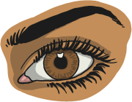
Practise Your Words!

Look

Say

Cover

Write

Check
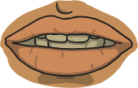
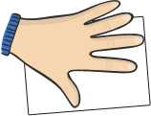
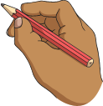


Words | Monday | Tuesday | Wednesday | Thursday | Friday
illegal
illegible
illogical
illiterate
illicit
irregular
irrelevant
irresponsible
irrational
irresistible

