Summer 11.05.2026-.15.05.2026
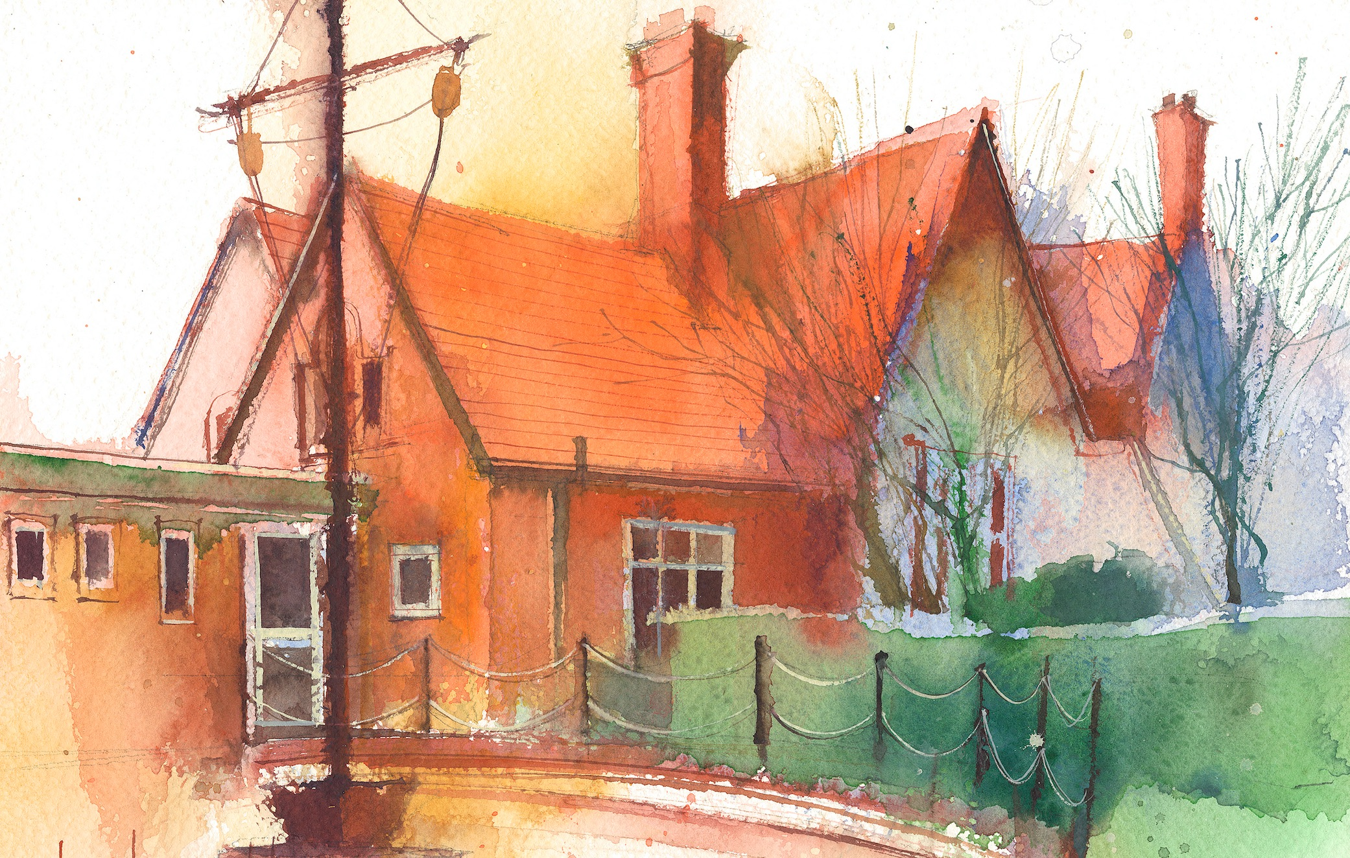
To contact your child’s class teacher, please email schooloffice@dawpool.wirral.sch.uk or phone 0151 648 3412
 | Lessons 09:00 - 10:30 |  | Lessons 10:45 - 12:15 |  | Lessons 13:15 - 15:30  (Incorporating 15-minute break) | Additional Tasks
Monday  27/04/26 | Mrs McCanns plans |  |  |  |  | Drama Club
Tuesday  28/04/26 | Maths to  By the end of this lesson your child should be able to: know how to order and compare decimals up to 3 places. Lesson 9 |  | CDAT English  By the end of this lesson your child should be able to: have read and seen the pictures in Wisp. To explore themes of hope and emotion through poetry. |  | Topic  By the end of this lesson your child should be able to: Understand the four layers of the rain forest and what they are made of. Then to label and place different animals from the rainforest in the correct layer, habitat.  Picture news, British Values | Future Medics Club
Wednesday  29/04/26 | Maths  Fluent in five/ Rapid Reasoning  By the end of this lesson your child should be able to: understand how to round up to the nearest whole number. Lesson 10 |  | CDAT English  By the end of this lesson your child should be able to: create vivid imagery using adjectives and adverbs using expanded noun phrases and using adverbs |  | PE  By the end of this lesson your child should be able to: Play a simple game of tag rugby always passing backwards or sideways and working as a team.  Handwriting | Chess Club
Thursday  30/04/26 | Fluent in five/ Rapid Reasoning  By the end of this lesson your child should be able to: understand how to round up to the nearest tenth. Lesson 11.  Whole school singing practise 9.10 |  | CDAT English  By the end of this lesson your child should be able to: use alliteration to create mood and rhythm and make their own short alliterative poem |  | Science  By the end of this lesson your child should be able to: know that materials will dissolve in liquid to form a solution and describe how to recover a substance from a solution, Lesson 2 Plymouth Scheme | Clubs cancelled Choir/Drama Netball Club
Friday  01/05/26 | Maths  Fluent in five/ Rapid Reasoning  By the end of this lesson your child should be able to: understand what percentages are. Lesson 12 |  | CDAT English  By the end of this lesson your child should be able to use figurative language and to deepen meaning using both similes and personification. |  | IT  By the end of this lesson your child should be able to: do coding on the laptops and know what homework they need to do on Purple Mash  Spanish  Handwriting | Celebration of weeks work

