Year 4 Weekly Timetable Au Week 4 Commencing: 23.09.26
To contact your child’s class teacher, please email schooloffice@dawpool.wirral.sch.uk or phone 0151 648 3412
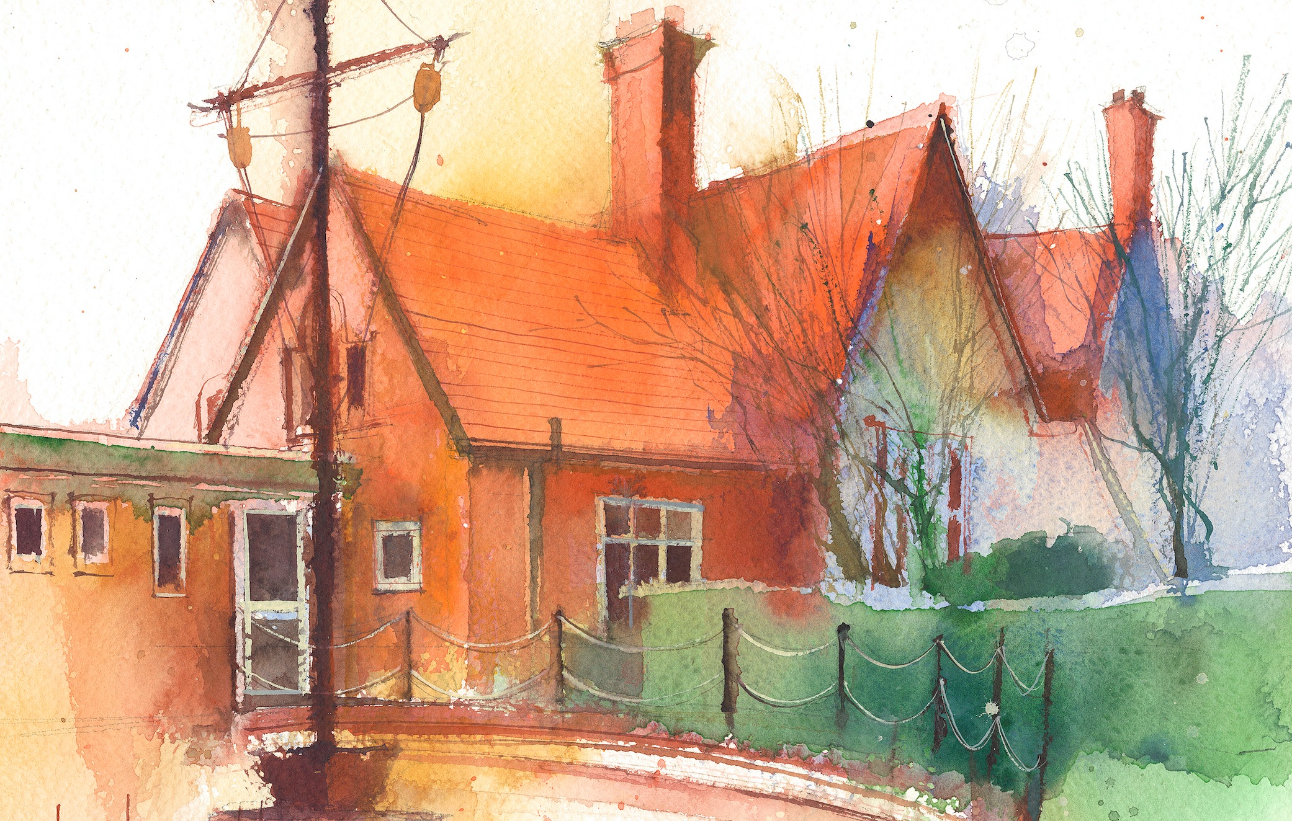

 | Lessons 09:00 – 10:30 |  | Lessons 10:45 – 12:15 |  | Lessons 13:15 – 15:30 (Incorporating 15-minute break) | Additional Tasks
Monday | Maths  Place Value  Estimate on a number line  Collective Worship 10:10 |  | English  Create |  | Science  Lesson 3  How to keep my teeth healthy  Picture News | Useful Links / Other Recommended Activities  Oak National Academy  https://classroom.thenational.academy/  BBC Bitesize  https://www.bbc.co.uk/bitesize  Purple Mash  https://www.purplemash.com/sch/dawpool#/  Times table practise:  https://www.timestables.co.uk/multiplication-tables-check/  Hit the button  https://www.topmarks.co.uk/maths-games/hit-the-button
Tuesday | Maths  Place Value  Compare numbers to 10,000  Class based worship: Heart Smart |  | English  Reading |  | Art  Lesson 3.
Wednesday | Maths  Place Value  Order numbers to 10,000 |  | Music  Ukelele  English  Comprehension |  | Geography  Rivers(2)  Describe the different steps in the water cycle.  Music
Thursday | Sing worship 9:10  Maths  Place Value  Roman Numerals |  | English  Reading |  | PE  Game sense invasion (3)  Spanish  Say and read numbers 0-20
Friday | Maths  Place Value  Round to 10  Celebration worship 10:10 |  | English  Reading |  | Computing  To understand what animation is  Spelling  Week 3

