Dawpool C.E. (Aided)
Primary School

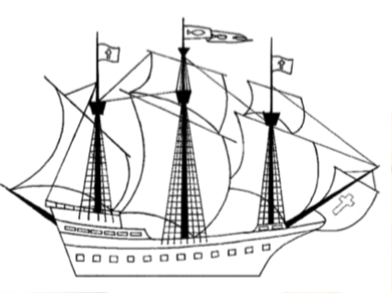
DAWPOOL
Year 5 Curriculum

Wisdom, Knowledge and Skills
Vision Statement
‘The Dawpool community are united in their ambition to create a school which embodies the person, love and work of Jesus Christ: a school which enables Christian values to flourish and where all children may experience the abundant life that Jesus offers.’

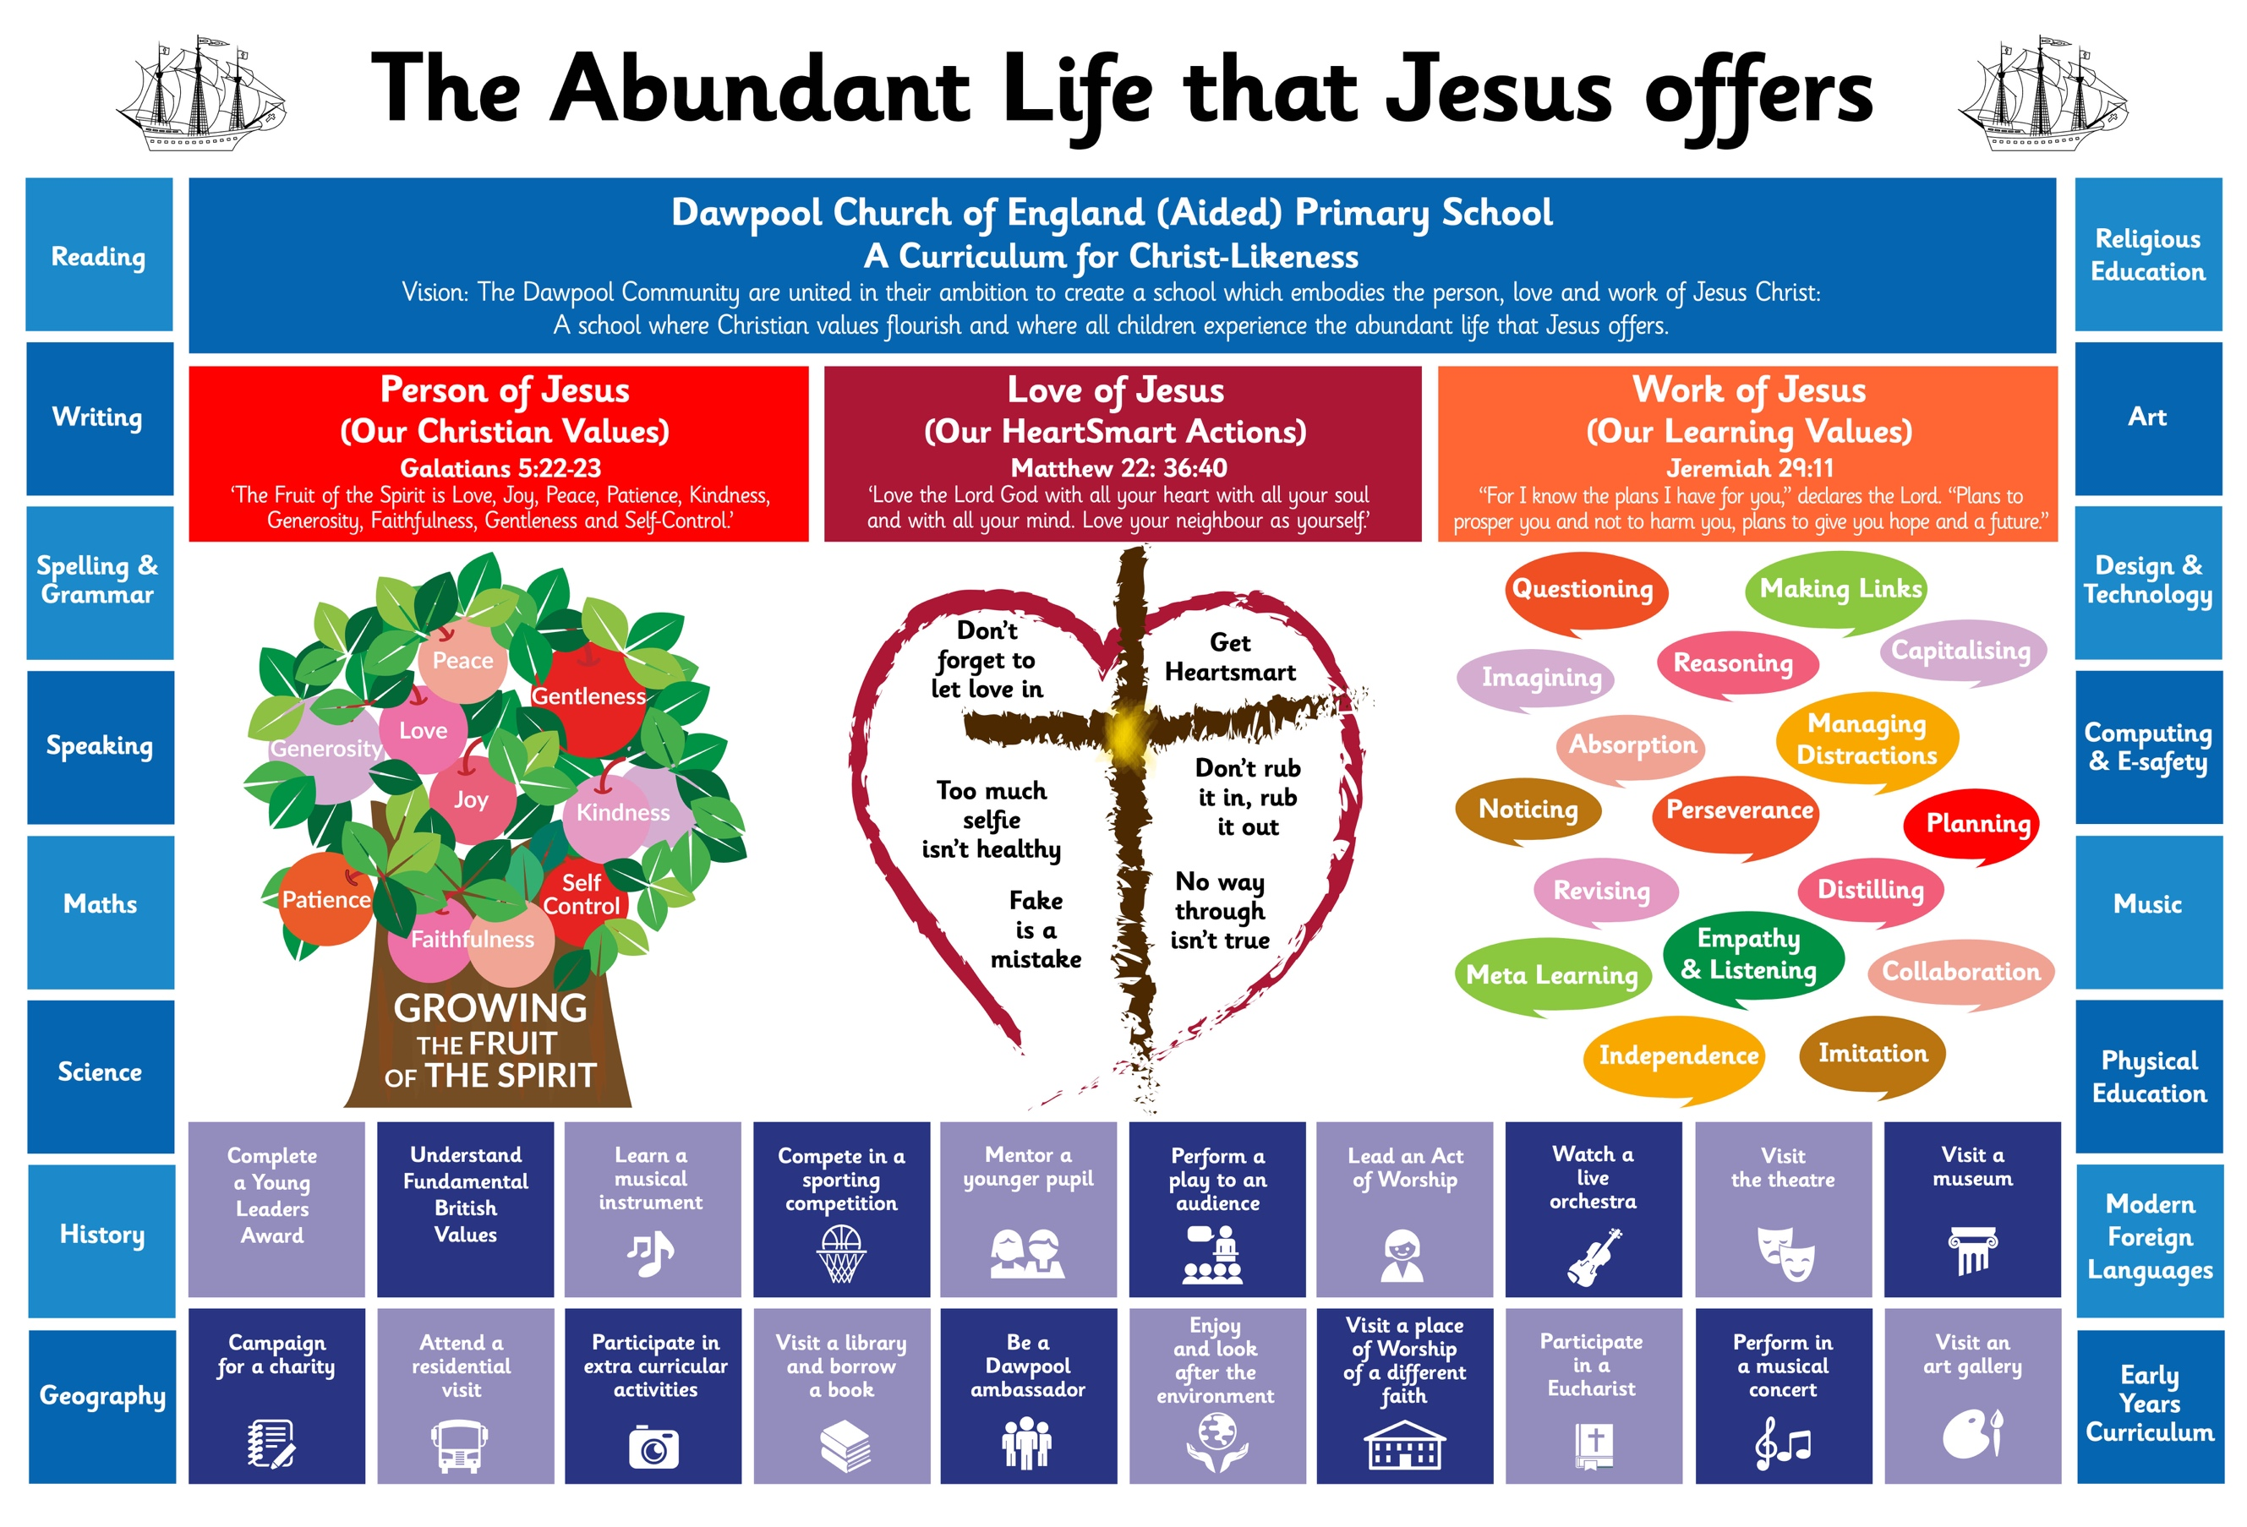
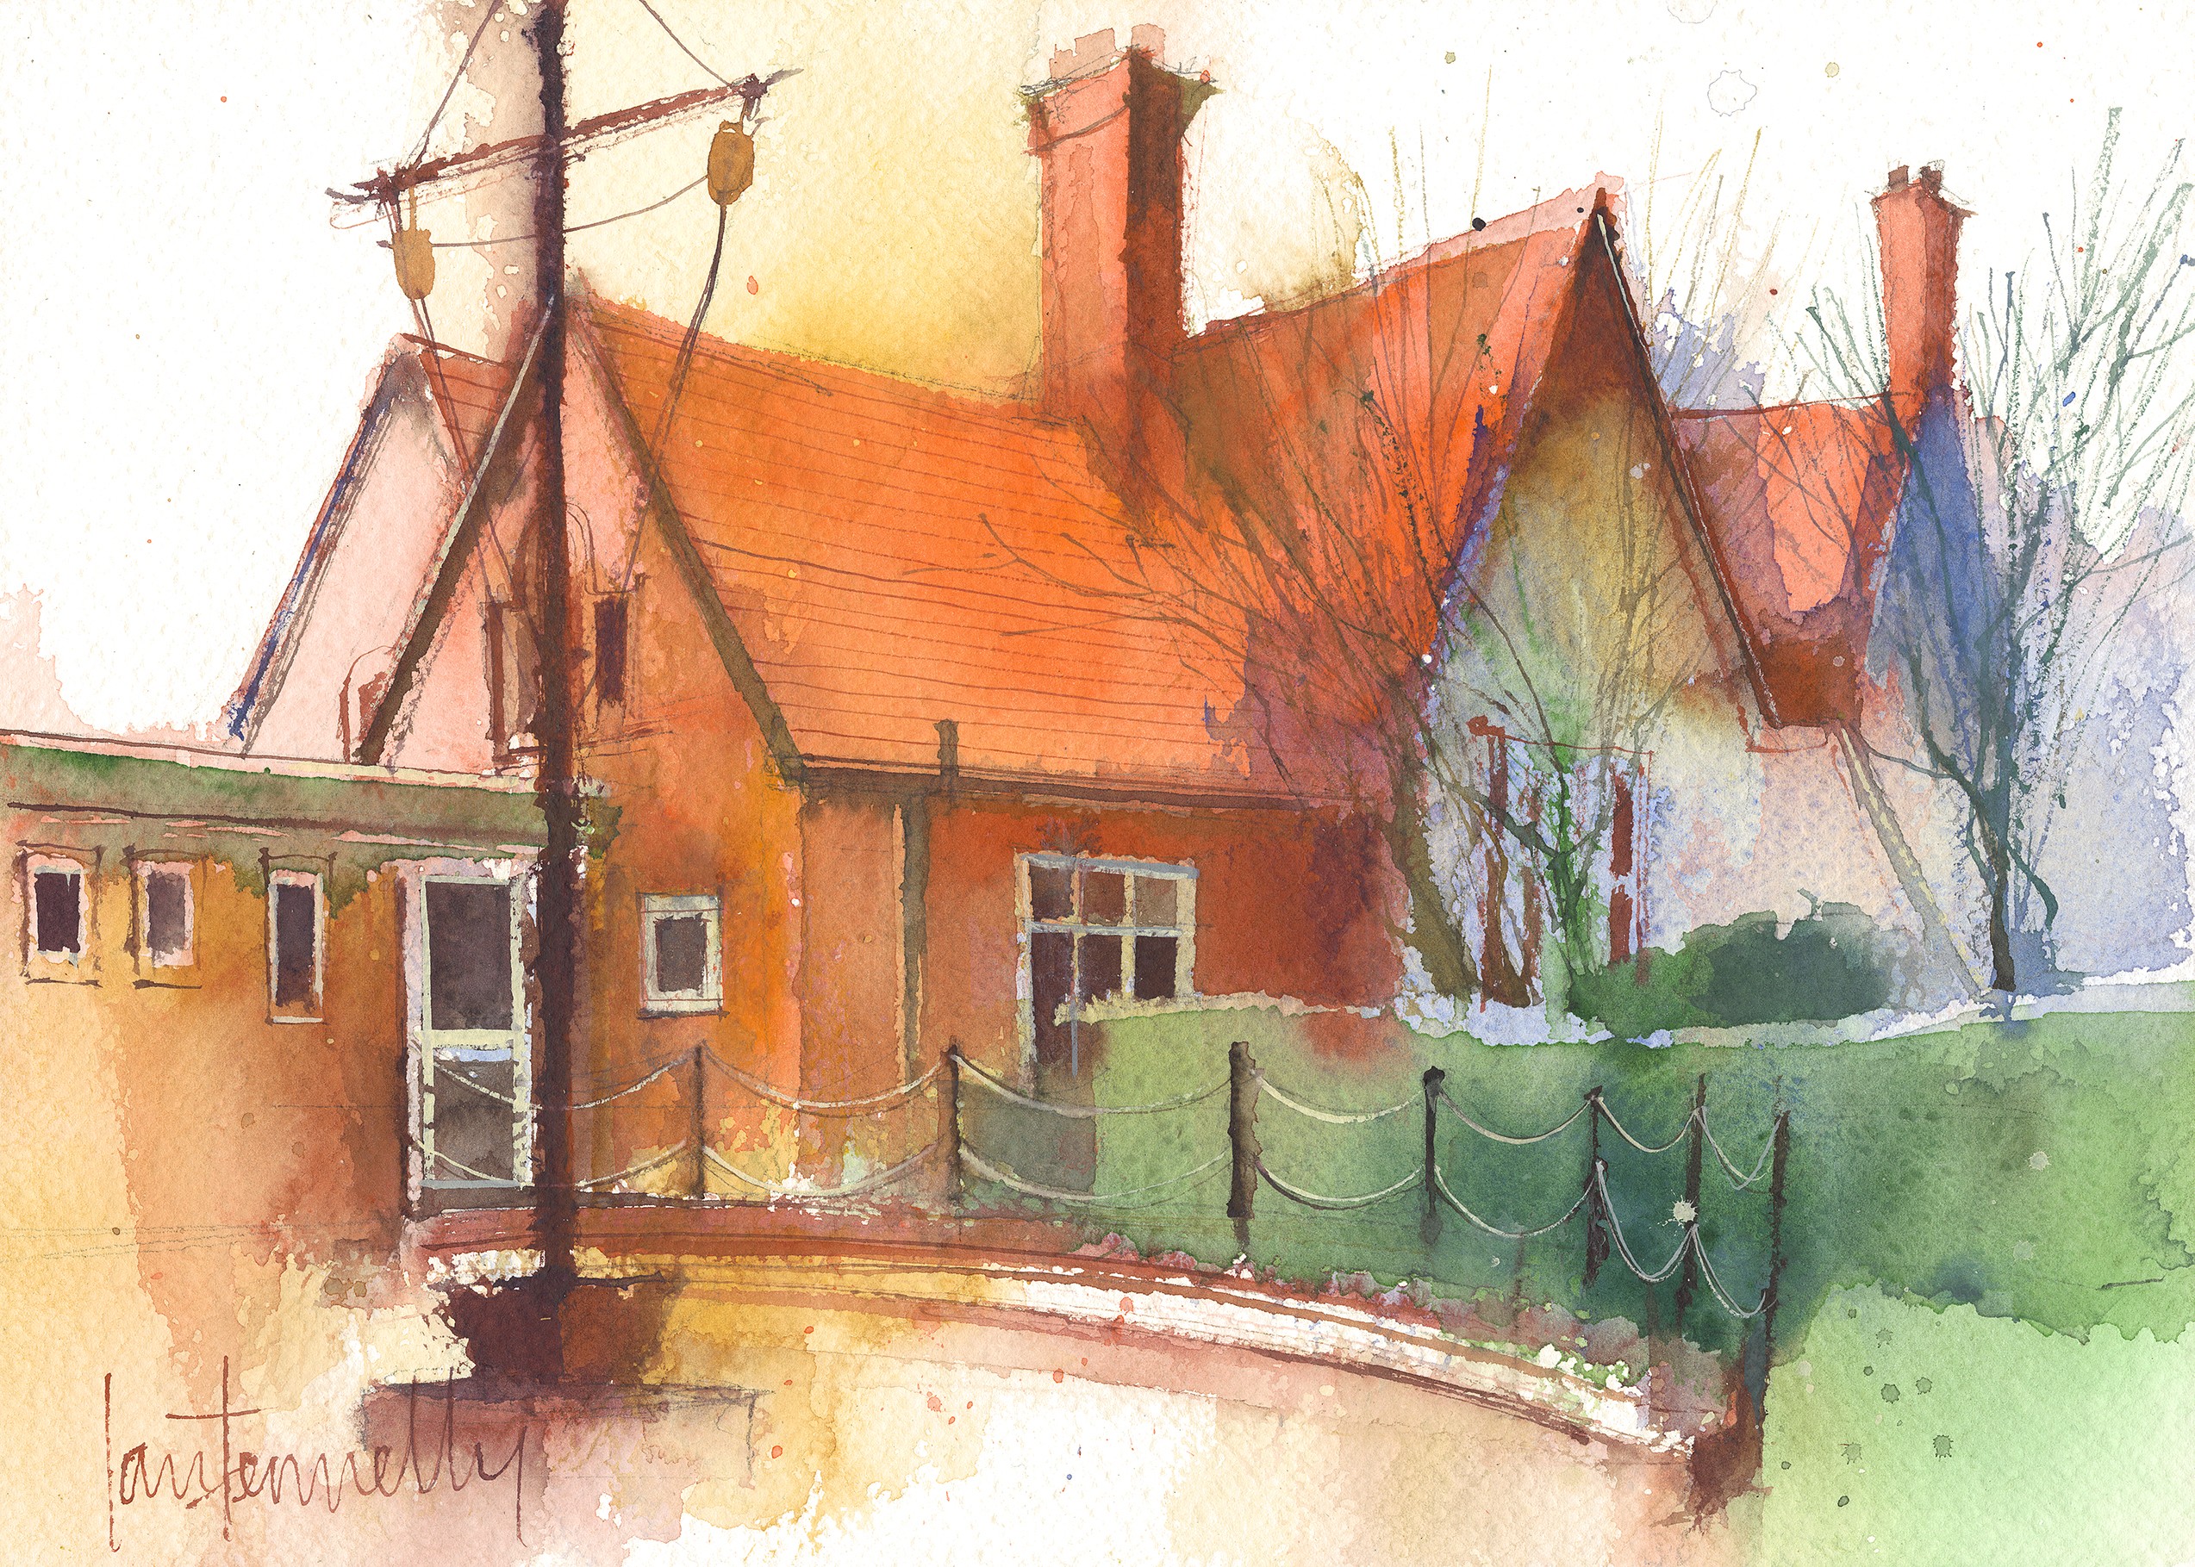
‘The Fruit of the Spirit is Love, Joy, Peace, Patience, Kindness, Generosity, Faithfulness, Gentleness and Self-Control’ (Galatians 5: 22-23).

Dawpool C.E (Aided) Primary School
School Lane
Thurstaston
Wirral
CH61 0HH

0151 648 3412
schooloffice@dawpool.wirral.sch.uk
www.dawpool-ce.eschools.co.uk
@DawpoolCofE
1
The Dawpool ‘Curriculum for Christ-Likeness’ 4
Year 5 Curriculum Topics 8
Year 5 Enrichment 8
Year 5 Reading Spine 8
A Year 5 Reader at Dawpool 9
Word Reading 9
Comprehension 9
Greater Depth in Reading 10
A Year 5 Writer at Dawpool 11
Transcription 11
Composition 11
Year 5/6 Statutory Spelling List 13
Vocabulary, Grammar and Punctuation 14
Greater Depth in Writing 15
A Year 5 Speaker at Dawpool 15
Greater Depth in Speaking 15
A Year 5 Mathematician at Dawpool 16
Number, place value, approximation and estimation/rounding 16
Calculations 16
Fractions, decimals and percentages 17
Measurement 18
Geometry – properties of shapes 18
Geometry – position and direction 18
Statistics 19
Greater Depth in Mathematics 19
A Year 5 Scientist at Dawpool 19
Working scientifically 19
Biology 20
Chemistry 20
Physics 21
Greater Depth in Science 21
Year 5 Scientific Vocabulary 21
A Year 5 Historian at Dawpool 22
Ancient Greece 23
Year 5 Historical Vocabulary 23
A Year 5 Geographer at Dawpool 23
South America 24
Brazil & Rainforests 24
Year 5 Geographical Vocabulary 24
A Year 5 Theologian at Dawpool 25
Year 5 Theological Vocabulary 28
A Year 5 Artist at Dawpool 28
Peter Thorpe Space Art 28
Greek Pots –Sculpting Vases 28
Rain Forests- Henri Rousseau 28
Watercolour Sunflowers 28
Bird Drawing and Feather Printing 29
Year 5 Art Vocabulary 29
A Year 5 Designer at Dawpool 29
Biscuits 29
Fashion and Textiles: Making a Drawstring Bag 29
Year 5 Design Vocabulary 30
A Year 5 Computer User at Dawpool 30
Algorithms and programming 30
Information technology 30
Digital literacy 31
A Year 5 Safe Computer User at Dawpool 31
Knowledge and understanding 31
Skills 31
Year 5 Computing Vocabulary 32
A Year 5 Musician at Dawpool 32
Year 5 Music Vocabulary 33
A Year 5 International Speaker at Dawpool 33
A Year 5 Sports Person at Dawpool 34
Games 34
Gymnastics 34
Dance 34
Athletics 34
Outdoor and adventurous 34
Year 5 PE Vocabulary 34

The Dawpool ‘Curriculum for Christ-Likeness’

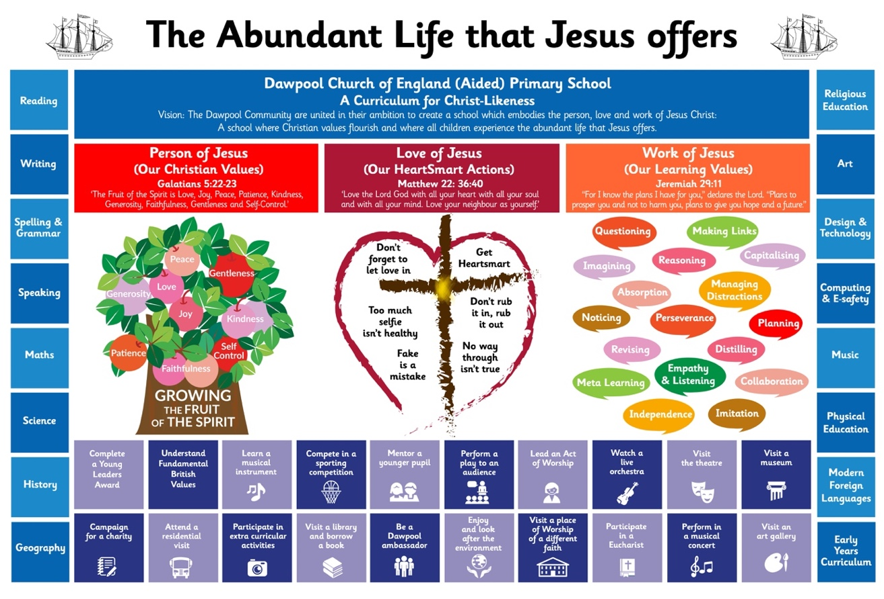

Vision Statement
‘The Dawpool community are united in their ambition to create a school which embodies the person, love and work of Jesus Christ: a school which enables Christian values to flourish and where all children may experience the abundant life that Jesus offers.’

The Dawpool curriculum is designed to:
- Embody the 'Person, Love and Work' of Jesus Christ.
- Enable 'Christian Values to Flourish'.
- Ensure that all pupils experience the ‘Abundant Life that Jesus offers.’

These three overarching objectives relate directly to the core principles of our vision statement.
The Person, Love and Work of Jesus are three golden threads that run through the heart of our curriculum
At Dawpool, we aim to embody the person of Jesus Christ by growing the Fruit of the Spirit. | At Dawpool, we aim to we embody the love of Jesus Christ by teaching pupils to be HeartSmart. | At Dawpool we aim to embody the work of Jesus Christ by teaching pupils core learning values.

We know that all of these values were demonstrated by Jesus in his life. They are also rooted in pedagogy, such as Guy Claxton’s ‘Building Learning Powers’ and Rosenshine’s ‘Principles of Instruction.’
In our curriculum planning we have taken each individual value - whether it be a Fruit of the Spirit, a HeartSmart action or a Learning Value - and directly referenced each one to the example of Jesus by providing a definition of the value, linking it to scripture and providing specific examples of how Jesus demonstrated it – see The Curriculum for Christ-Likeness. By teaching the children how to emulate these values we enable Christian values to flourish through our curriculum.
Dawpool’s focus on developing Christian and learning values through the curriculum encourages children to stretch themselves spiritually, morally, intellectually, imaginatively and actively. The impact of Dawpool’s Curriculum for Christ-Likeness is that pupils are curious, confident and resilient learners who develop a sense of character and enjoy their learning. The Dawpool Curriculum places emphasis on character development and wider flourishing, recognising that these are fundamental to any sustained academic success.
The image below provides an overview of what the Person, Love and Work of Jesus looks like at a classroom level. Whether it be a Science lesson or a History lesson, there are familiar characteristics of effective learning:
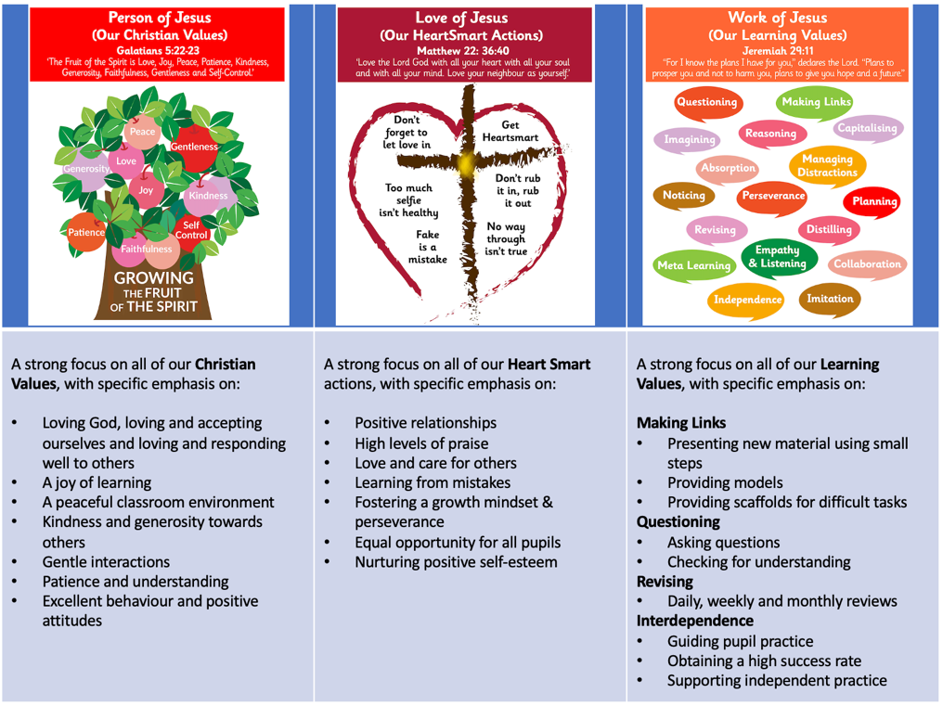
Jesus’ greatest commandment (Matthew 22:36-40) is central to the life of Dawpool: Loving God, loving and accepting ourselves and loving and responding well to others.
The next part of our curriculum is to ensure that all pupils experience the ‘Abundant Life that Jesus Offers’. This is defined as enabling all children to experience the full curriculum – it’s not narrowed for any child. We aim to nurture children’s God-given talents and provide for their intellectual, emotional, personal, social, spiritual and physical development.
We provide a subject-specific curriculum in which we have mapped out the knowledge and skills that we want children to learn at each stage (See the ‘Wisdom, Knowledge and Skills’ documents for each year group and the subject specific documents).

The Subject Specific Curriculum
For each subject, we have carefully established the expectations for timetabling, planning, marking and assessment to ensure that the curriculum is delivered fully to all pupils – see the Curriculum Implementation Handbook.
Where possible, subjects are delivered through topics which are designed for maximum engagement and ensure all pupils benefit from a rich, broad, balanced curriculum presented in an interesting, exciting and imaginative manner with lots of opportunities for first-hand experience, practical work, investigation and learning through play. The curriculum is enriched with visits, visitors, and extensive use of our unique environment.
Our ‘local curriculum’ provides for an informal programme of enrichment and extra-curricular activities which is made up of those activities that we feel all children should experience at least once during their time in school, but in reality, there is likely to be several opportunities for each child. Such activities include: completing a young leaders award, learning a musical instrument, mentoring a younger pupil and leading an Act of Worship.

The Local Curriculum

Therefore, Dawpool’s full curriculum incorporates the Person, Love and Work of Jesus as three golden threads running through the curriculum with Jesus’ greatest commandment at its heart. it includes our subject-specific curriculum and our local curriculum of enrichment and extra-curricular activities.

Year 5 Curriculum Topics

Where appropriate, the vocabulary, knowledge and skills for Year 5 are delivered through the following broad topics:

 | Autumn | Spring | Summer
Y5 | Ancient Greece | South America | Rainforests & Brazil

Year 5 Enrichment

Year 5 Reading Spine

English Curriculum | Reading for Pleasure | No Outsiders
The Adventures of Odysseus  50 Greek Myths  The Explorer, Katherine Rundell  Journey to the River Sea, Eva Ibbotson  Roger McGough (Poetry) | Archaic:  If, Rudyard Kipling  (poem)  Non-Linear Time Sequences:  Holes, Louis Sachar  Complexity of the Narrator:  Pax, Sara Pennypacker  Complexity of Plot/Symbol:  Dreams, Langston Hughes (poem)  Resistant Texts:  The Pobble Who Had No Toes (poem) | Kenny Lives with Erica and Martina  Rose Blanche  Mixed  How to Heal a Broken Wing  The Girls  And Tango Makes Three

A Year 5 Reader at Dawpool

Word Reading

- I can apply my knowledge of root words, prefixes and suffixes to read aloud and to understand the meaning of unfamiliar words.
- I can read further exception words, noting the unusual correspondences between spelling and sound.
- I attempt pronunciation of unfamiliar words drawing on prior knowledge of similar looking words.
- I can re-read and read ahead to check for meaning.

Comprehension

- I am familiar with and can talk about a wide range of books and text types, including myths, legends and traditional stories and books from other cultures and traditions. I can discuss the features of each.
- I can read non-fiction texts and identify the purpose, structure and grammatical features, evaluating how effective they are.
- I can identify significant ideas, events and characters; and discuss their significance.
- I can recite poems by heart, e.g. narrative verse, haiku.
- I can prepare poems and plays to read aloud and to perform, showing understanding through intonation, tone, volume and action.
- I can use meaning-seeking strategies to explore the meaning of words in context.
- I can use meaning-seeking strategies to explore the meaning of idiomatic and figurative language.
- I can identify and comment on a writer’s use of language for effect. for example, precisely chosen adjectives, similes and personification.
- I can identify grammatical features used by the writer (rhetorical questions, varied sentence lengths, varied sentence starters, empty words) to impact on the reader.
- I can draw inferences such as inferring characters' feelings, thoughts and motives from their actions.
- I can justify inferences with evidence from the text.
- I can make predictions from what has been read.
- I can summarise the main ideas drawn from a text.
- I can identify the effect of the context on a text; for example, historical context or other cultures.
- I can identify how language, structure and presentation contribute to the meaning of a text.
- I can express a personal point of view about a text, giving reasons.
- I can make connections between other similar texts, prior knowledge and experience.
- I can compare different versions of texts and talk about their differences and similarities.
- I can listen to and build on others’ ideas and opinions about a text.
- I can present an oral overview or summary of a text.
- I can present the author’s viewpoint of a text.
- I can present a personal point of view based on what has been read.
- I can listen to others’ personal point of view.
- I can explain a personal point of view and give reasons.
- I know the difference between fact and opinion.
- I can use my knowledge of structure of text type to find key information.
- I can use text marking to identify key information in a text.
- I can make notes from text marking.

Greater Depth in Reading

- I can express opinions about a text, using evidence from the text, giving reasons and explanations. (Point, evidence, explanation)
- I can adapt my own opinion in the light of further reading or others’ ideas.
- I can identify formal and informal language .
- I know the features of different narrative text types, for example, adventure, fantasy, myths.
- I can compare texts by the same writer.
- I can compare texts by different writers on the same topic.
- I can summarise key information from different texts.
- I can empathise with different characters’ points of view.
- I can infer meaning using evidence from the text and wider reading and personal experience.
- I can explain how a writer’s use of language and grammatical features have been used to create effects and impact on the reader.
- I can explain how punctuation marks the grammatical boundaries of sentences and gives meaning.
- I know how the way a text is organised supports the purpose of the writing.
- I can use scanning and text marking to find and identify key information.

A Year 5 Writer at Dawpool

Transcription

Spelling
- I can form verbs with prefixes.
- I can convert nouns or adjectives into verbs by adding a suffix.
- I understand the rules for adding prefixes and suffixes.
- I can spell words with silent letters.
- I can distinguish between homophones and other words which are often confused.
- I can spell the commonly mis-spelt words from the Y5/6 word list.
- I can use the first 3 or 4 letters of a word to check spelling, meaning or both in a dictionary.
- I can use a thesaurus.
- I can use a range of spelling strategies.

Handwriting

- I can choose the style of handwriting to use when given a choice.
- I can choose the handwriting that is best suited for a specific task.

Composition

- I can discuss the audience and purpose of the writing.
- I can start sentences in different ways.
- I can use the correct features and sentence structure matched to the text type we are working on.
- I can develop characters through action and dialogue.
- I can establish a viewpoint as the writer through commenting on characters and events.
- I can use grammar and vocabulary to create an impact on the reader.
- I can use stylistic devices to create effects in writing.
- I can add well-chosen detail to interest the reader.
- I can summarise a paragraph.
- I can organise my writing into paragraphs to show different information or events.

Year 5/6 Statutory Spelling List

Vocabulary, Grammar and Punctuation

Word

- I can convert nouns or adjectives into verbs using suffixes [for example, –ate; –ise; –ify]
- I can use verb prefixes [for example, dis–, de–, mis–, over– and re–]

Sentence

- I can use relative clauses beginning with who, which, where, when, whose, that, or an omitted relative pronoun
- I can indicate degrees of possibility using adverbs [for example, perhaps, surely] or modal verbs [for example, might, should, will, must

Text

- I can use devices to build cohesion within a paragraph [for example, then, after that, this, firstly]
- I can link ideas across paragraphs using adverbials of time [for example, later], place [for example, nearby] and number [for example, secondly] or tense choices [for example, he had seen her before]

Punctuation

- I can use brackets, dashes or commas to indicate parenthesis
- I can use commas to clarify meaning or avoid ambiguity

Terminology

- modal verb, relative pronoun, relative clause, parenthesis, bracket, dash cohesion, ambiguity

Greater Depth in Writing

- I can use paragraphs to structure the plot in narrative writing, showing changes in time, place and events.
- I can use changes in time and place to guide the reader through the text.
- I can use paragraphs to organise information logically and shape a non-fiction text effectively.
- I can sustain and develop an idea within a paragraph, introducing it with a topic sentence.
- I can close text with reference to its opening.
- I can re-order sentences to create an impact on the reader.
- I can use expanded noun phrases to add well thought out detail to writing.
- I can use punctuation to clarify the meaning of sentences e.g. commas to mark phrases and clauses.
- I can use dialogue effectively and punctuate it accurately.

A Year 5 Speaker at Dawpool

- I can engage the listener by varying my expression and vocabulary.
- I adapt my spoken language depending on the audience, the purpose or the context.
- I can develop my ideas and opinions, providing relevant detail.
- I can express my point of view.
- I show that I understand the main points, including implied meanings in a discussion.
- I listen carefully in discussions. I make contributions and ask questions that are responsive to others’ ideas and views.
- I use Standard English in formal situations.
- I am beginning to use hypothetical language to consider more than one possible outcome or solution.
- I can perform my own compositions, using appropriate intonation and volume so that meaning is clear.
- I can perform poems and plays from memory, making careful choices about how I convey ideas. I adapt my expression and tone.
- I am beginning to select the appropriate register according to the context.

Greater Depth in Speaking

- I can organise and shape a talk, making connections between ideas and drawing on different points of view.
- I can use Standard English appropriately.
- I can use persuasive language and techniques to influence the listener.
- I show an understanding of how and why language choices vary in my own and others’ talk in different contexts.
- I can sustain listening to different sources, retaining or noting key information.
- I can speak in extended turns to express ideas and opinions, with some relevant detail.
- I can vary vocabulary, grammar, and non-verbal features to suit the audience, purpose, and context.
- I can sustain listening to different sources, retaining or noting key information.
- I can listen to others in discussion and link my own ideas clearly to others’ views.

A Year 5 Mathematician at Dawpool

Number, place value, approximation and estimation/rounding

- I can count forwards or backwards in steps of powers of 10 for any given number up to 1,000,000.
- I can read, write, order and compare numbers to at least 1,000,000.
- I can determine the value of each digit in numbers up to 1,000,000.
- I can read Roman numerals to 1,000 (M) and recognise years written in Roman numerals.
- I can round any number up to 1,000,000 to the nearest 10, 100, 1000, 10000 and 100000.
- I can interpret negative numbers in context, count forwards and backwards with positive and negative whole numbers, including through zero.
- I can solve number problems and practical problems with the above.

Calculations

- I can add and subtract numbers mentally with increasingly large numbers.
- I can add and subtract whole numbers with more than 4 digits, including using formal written methods.
- I can use rounding to check answers to calculations and determine, in the context of a problem, levels of accuracy.
- I can solve addition and subtraction multi-step problems in contexts, deciding which operations and methods to use and why.
- I can identify multiples and factors, including finding all factor pairs or a number and common factor pairs of two numbers.
- I use the vocabulary of prime numbers, prime factors and composite (non-prime) numbers.
- I can establish whether a number up to 100 is prime and recall prime numbers up to 19.
- I recognise and use square numbers and cube numbers, and the notation for squared and cubed.
- I can multiply and divide numbers mentally drawing on known facts.
- I can multiply and divide whole numbers and those involving decimals by 10, 100 and 1000.
- I can multiply numbers up to 4 digits by a 1-digit or 2-digit number using a formal written method, including long multiplication for 2-digit numbers.
- I can divide numbers up to 4 digits by a 1-digit number using the formal written method of short division and interpret remainders appropriately for the context.
- I can solve problems involving multiplication and division including using knowledge of factors and multiples, squares and cubes.
- I can solve problems involving addition, subtraction, multiplication and division and a combination of these, including understanding the meaning of the equals sign.
- I can solve problems involving multiplication and division including scaling by simple fractions and problems involving simple rates.

Fractions, decimals and percentages

- I can recognise mixed numbers and improper fractions and convert from one form to the other.
- I can write mathematical statements >1 as a mixed number.
- I can identify, name and write equivalent fractions of a given fraction, represented visually, including tenths and hundredths.
- I can compare and order fractions whose denominators are multiples of the same number.
- I can add and subtract fractions with the same denominator and denominators that are multiples of the same number.
- I can multiply proper fractions and mixed numbers by whole numbers, supported by materials and diagrams.
- I can read and write decimal numbers as fractions.
- I recognise and can use thousandths and relate them to tenths, hundredths and decimal equivalents.
- I can round decimals with 2 decimal places to the nearest whole number and 1 decimal place.
- I can read, write, order and compare numbers with up to 3 decimal places.
- I can solve problems involving numbers up to 3 decimal places.
- I recognise the percent symbol and understand that percent relates to ‘number parts per hundred’.
- I can write percentages as a fraction with denominator hundred, and as a decimal.
- I can solve problems which require knowing percentage and decimal equivalents of ½, ¼, 1/5, 2/5, 4/5 and those fractions with a denominator or a multiple of 10 or 25.

Measurement

- I can solve problems involving converting between units of time.
- I can convert between different units of metric measure.
- I understand and use approximate equivalences between metric units and common imperial units, such as inches, pounds and pints.
- I can measure and calculate the perimeter of composite rectilinear shapes in cm and m.
- I can calculate and compare the area of rectangles (incl. squares), and including using standard units (cm2 and cm3) to estimate the area of irregular shapes.
- I can estimate volume and capacity.
- I can use all four operations to solve problems involving money using decimal notation, including scaling.

Geometry – properties of shapes

- I can use the properties of rectangles to deduce related facts and find missing lengths and angles.
- I can distinguish between regular and irregular polygons based on reasoning about equal sides and angles.
- I can identify 3D shapes, including cubes and other cuboids, from 2D representations.
- I know angles are measured in degrees.
- I can estimate and compare acute, obtuse and reflex angles.
- I can identify angles at a point and one whole turn.
- I can identify angles at a point on a straight line and ½ a turn.
- I can identify other multiples of 90º.
- I can draw given angles and measure them in degrees.

Geometry – position and direction

- I can identify, describe and represent the position of a shape following a reflection or translation, using the appropriate language, and know that the shape has not changed.

Statistics

- I can complete, read and interpret information in tables, including timetables.
- I can solve comparison, sum and difference problems using information presented in a line graph.

Greater Depth in Mathematics

- I have a concept of numbers well beyond 1,000,000 and their relative association to distances to planets; historical data and geographical aspects.
- I can divide whole numbers (up to 4 digits) by 2-digit numbers, using my preferred method.
- I can use rounding as a strategy for quickly assessing what approximate answers ought to be before calculating.
- I can link working across zero for positive and negative numbers, for example, to work out time intervals between BC and AD in history
- I can recognise the symbol for square root (√) and work out square roots for numbers up to 100.
- I can calculate number problems algebraically, for example, 2x – 3 = 5
- I can use my knowledge of measurement to create plans of areas around school, such as the classroom , field, outside play area, etc.
- I can relate the imperial measures still used regularly in our society to their metric equivalents, for example, miles to Km and lbs to Kg.
- I can use a range of timetables to work out journey times on a fictional journey around the world, for example, “How long would it take to reach the rainforests in the Amazon?”
- I can collect my own data on a personal project and present information in formats of my choosing using charts, graphs and tables.

A Year 5 Scientist at Dawpool

Working scientifically

- I can plan different types of scientific enquiry.
- I can control variables in an enquiry.
- I can measure accurately and precisely using a range of equipment.
- I can record data and results using scientific diagrams and labels, classification keys, tables, scatter graphs, bar and line graphs.
- I can use the outcome of test results to make predictions and set up a further comparative fair test.
- I can report findings from enquiries in a range of ways.
- I can explain a conclusion from an enquiry.
- I can explain causal relationships in an enquiry.
- I can relate the outcome from an enquiry to scientific knowledge in order to state whether evidence supports or refutes an argument or theory.
- I can read, spell and pronounce scientific vocabulary accurately.

Biology

Living things and their habitats
- I can describe the life cycle of different living things, e.g. mammal, amphibian, insect bird.
- I can describe the differences between different life cycles.
- I can describe the process of reproduction in plants.
- I can describe the process of reproduction in animals.

Animals, including humans
- I can create a timeline to indicate stages of growth in humans.

Chemistry

Properties and changes of materials
- I can compare and group materials based on their properties (e.g. hardness, solubility, transparency, conductivity, [electrical & thermal], and response to magnets).
- I can describe how a material dissolves to form a solution; explaining the process of dissolving.
- I can describe and show how to recover a substance from a solution.
- I can describe how some materials can be separated.
- I can demonstrate how materials can be separated (e.g. through filtering, sieving and evaporating).
- I know and can demonstrate that some changes are reversible and some are not.
- I can explain how some changes result in the formation of a new material and that this is usually irreversible.
- I can discuss reversible and irreversible changes.
- I can give evidenced reasons why materials should be used for specific purposes.

Physics

Earth and space
- I can describe and explain the movement of the Earth and other planets relative to the Sun.
- I can describe and explain the movement of the Moon relative to the Earth.
- I can explain and demonstrate how night and day are created.
- I can describe the Sun, Earth and Moon (using the term spherical).

Forces
- I can explain what gravity is and its impact on our lives.
- I can identify and explain the effect of air resistance.
- I can identify and explain the effect of water resistance.
- I can identify and explain the effect of friction.
- I can explain how levers, pulleys and gears allow a smaller force to have a greater effect.

Greater Depth in Science

- I can explore different ways to test an idea, choose the best way and give reasons.
- I can vary one factor whilst keeping the others the same in an experiment.
- I can use information to help make a prediction.
- I can explain (in simple terms) a scientific idea and what evidence supports it.
- I can create a timeline to indicate the stages of growth in certain animals, such as frogs and butterflies.
- I can observe my local environment and draw conclusions about life-cycles, for example, the vegetable garden or plants in a shrubbery.
- I can describe methods for separating mixtures, for example, filtration, distillation.
- I can compare the time of day at different places on Earth.
- I can describe and explain how motion is affected by forces, for example, gravitational attractions, magnetic attraction and friction.
- I can work out how water can cause resistance to floating objects.

Year 5 Scientific Vocabulary

gestation | fetus | fertilisation | species
baby | toddler | adolescent | adult
elderly person | puberty | hormones | pituitary gland
earth | axis | rotate | star
sun | planet | planet names | full moon
half moon | crescent moon | new moon | waxing
waning | lunar month | orbit | revolve
sphere | gravity | friction | air resistance
upthrust | weight | newton meter | Newtons
particles | surface area | push | pull
balance | mass | grams | kilograms
gear | lever | pulley | spring
amphibian | reptile | bird | mammal
insect | fish | egg | larva
pupa | nymph | adult | metamorphosis
petal | stamen | anther | filament
pollination | fertilisation | germination
thermal | conductor | insulator | electrical
solvent | solution | solute | soluble
insoluble | solid | liquid | particles
suspension | sieve | filter | evaporate
condense

A Year 5 Historian at Dawpool

All topics must begin with chronological knowledge, identifying the period of history on the corridor timeline.

Ancient Greece
- I know when and where the Ancient Greeks lived and how we know from evidence.
- I know the Democratic system was created by the Ancient Greeks. I can compare it to our modern day democracy and who has the right to vote in our country.
- I know about Greek gods and goddesses.
- I know about the Ancient Greeks created the Olympic games and can compare them to the modern games.
- I know about Pheidippides and the Battle of Marathon.
- I about the legacy of Ancient Greece.

- I can draw a timeline with different historical periods showing key historical events or lives of significant people, including Ancient Greece
- I can summarise how Britain may have learnt from other countries and civilizations (historically and more recently).
- I can compare two or more historical periods; explaining things which changed and things which stayed the same.
- I can explain how Parliament affects decision making in England.
- I can test out a hypothesis in order to answer questions.
- I can use research skills to find answers to specific historical questions about Ancient Greece.

Year 5 Historical Vocabulary

Empire | gods/goddesses | Marathon | weapons
Democracy | Olympus | Temple | armour
Government | myths | Theatre | City State
Slaves | Parthenon | Stadium | battle
Citizen | Olympics | Hoplite | Acropolis

A Year 5 Geographer at Dawpool

All topics begin with location knowledge:
Upper KS2 – The Americas
Include human features: major cities, natural resources, settlement, trade, land use patterns and how these change over time etc.
Include physical features: rivers, lakes, mountains, coasts etc

South America

Brazil & Rainforests
- I know where the rainforests, Equator and Tropics are located using a globe and maps.
- I know the layers of a rain forest.
- I know the causes and effects of deforestation.
- I know the climate is different in Brazil to London.
- I know the importance of Fair Trade to indigenous people in Brazil.
- I know where South America and Brazil are on a globe and on a map.
- I know about Brazil through research.

- I can plan a journey to a place in another part of the world, taking account of distance and time.
- I can explain how a location fits into its wider geographical location with reference to human and economical features.
- I can locate the Tropic of Cancer and Tropic of Capricorn.
- I can explain why deforestation occurs.
- I understand what is meant by the term ‘fairtade’.
- I can explain how a locality is affected by tourism.

Year 5 Geographical Vocabulary

Rain forest | biodiversity | deforestation | Eco system
Emergent layer | habitat | extinct | Equatorial
Under storey | tropical | indigenous | Fair Trade
Forest floor | evergreen | Tropics | Carbon-dioxide
liana | canopy | Equator | humid

A Year 5 Theologian at Dawpool

The Bible
- I know that Christians believe that the Bible is the inspired word of God.
- I know that there are many translations of the Bible and that the Bible guides Christians and effects their daily lives.
- I can tell you about the work of Bible translators today and in the past.
- I can explain how the teaching in the Bible helps to answer ultimate and ethical questions.
- I know about the origin and content of holy books from the world faiths I have investigated and the impact of these scriptures on the lives of believers.
- I can use religious vocabulary to show I understand texts from the holy books I have investigated and talk about the similarities and differences between them.
- I can describe the impact of the Torah on Jewish people, identify a Torah Scroll, yad, mantle and Ark and explain (using religious vocabulary) the difference between the Torah and the Talmud.
- I can talk about the contents of the Qur’an and Hadith and know the difference between the two.
- I can describe and make links between Malala’s behaviour and the teachings of the Qur’an.
- I can interpret and discuss quotes from sacred scriptures in the light of a current situation in the news.
Christmas
- I know that the nativity story is found in the Gospels of Matthew and Luke.
- I know the true meaning of Christmas is a celebration of the birth of Jesus, the Son of God, Messiah.
- I know where the nativity fits into God’s Big Story.
- I can identify which parts of the nativity story can be found in each Gospel amd can tell you about the audiences Matthew and Luke were writing for.
- I can identify the influence the two stories have on our Christmas celebrations.
- I can describe the Christian beliefs revealed in the nativity story.
- I can talk about why the flight to Egypt is a significant event.
Jesus
- I know that Jesus’ teaching explains Christian beliefs and that it makes an impact on people’s lives.
- I know the elements of Jesus teaching that can be directly linked to our school Christian values and British values.
- I can retell the Bible stories we have explored in the unit and ask important and relevant questions that improve my learning.
- I can use religious vocabulary to describe the Christian beliefs revealed in Jesus’ teaching and explain how this teaching is used to answer the big questions in life.
- I can identify one of Jesus’ parables that has a strong message for today and explain my choice.
Easter
- I know that Christians believe that Christ’s resurrection is a victory over death.
- I know that Christians believe that Easter is the key event in God’s salvation plan.
- I know that Christians believe Jesus’ death and resurrection restored the relationship between God and people.
- I can retell the Easter Story in detail and talk with understanding about the Christian belief that Jesus died and rose victoriously and what that means to Christians.
- I can ask important questions about Christian belief.
- I can talk about and describe feelings in relation to situations of victory and make links between people’s values, commitments, attitudes and behaviour with regard to situations of victory.
- I can reflect thoughtfully on the answers to big questions about Jesus’ death and resurrection.
- I can explain why Christians believe Jesus’ death and resurrection are a victory and explain the impact of believing in Jesus’ death and resurrection on a person’s life.
Old Testament Women
- I know the stories of significant women in the Old Testament.
- I know the Jewish Festival of Purim celebrates how God used Esther to save his people.
- I know that being a person of faith isn’t always easy.
- I can respond sensitively to questions about my own experiences and those of others and make a link between my own values and the values and commitments of the women in the Bible.
- I can use religious vocabulary to show that I understand the actions and beliefs of the women in the Old Testament and describe what inspires me about them.
- I can ask good questions and suggest answers about belonging, commitment, truth and values.
- I can talk about the impact the lives of the women whose stories I explored had on God’s great salvation plan.
Loss, Death and Christian Hope
- I know Christians believe that through the death and resurrection of Jesus they have the promise of eternal life with God in heaven.
- I know that Christians believe that when you die your spirit goes to be with God in heaven.
- I know Muslims believe that after death there is either paradise or hell. Good deeds in life enable entry into paradise.
- I know Hindus and Buddhists believe in samsara and reincarnation until enlightenment or freedom from desire is achieved.
- I can express my own opinion about what I think happens when you die.
- I can talk about what the Bible says heaven will be like, what I think heaven is like and make links between what the Bible says and what Christians believe.
- I can use the right language to show I understand what Christians believe about death and heaven.
- I can talk about similarities and differences between what world faiths say on the subject of death and heaven (including Hindu and Buddhist belief in samsara and reincarnation.)
- I can identify Christian beliefs in the words of songs and prayers.
- I can describe the funeral traditions of the world faiths I have explored.
Daniel
- I know the stories of Daniel and Shadrach, Meshach and Abednego.
- I know that Bible stories reveal the nature of God.
- I know about persecuted Christians and the challenges they face.
- I can talk knowledgeably about Christians being persecuted.
- I can talk about the ways in which the stories in the Bible encourage and motivate believers.
- I can talk knowledgeably about Jewish dietary laws.
- I can express my opinion about the decisions made by Daniel and his friends

Year 5 Theological Vocabulary

Old Testament | New Testament | Gospel | Word of God
translation | Saviour | Messiah | Gospel
Matthew | Luke | nativity | Herod
incarnation | salvation | Parable | Kingdom of God
Imagery | Victory | triumph | resurrection
sacrifice | salvation | redeemer | Jochebed
Deborah | Abigail | Rahab | Hannah
Ruth | Esther | Purim | Life
death | heaven | eternal life | funeral
reincarnation | hope | Daniel | Shadrach
Meshach | Abednego | Nebuchadnezzar | Darius

A Year 5 Artist at Dawpool

Peter Thorpe Space Art
- I know Peter Thorpe’s artistic style and can use it to replicate my own.
- I know what abstract art is.
- I can draw objects.
- I can draw on my learning about Earth and Space in Science for my art work.
- I can evaluate my work against criteria.

Greek Pots –Sculpting Vases
- I know about artists and crafts people.
- I know about different containers.
- I know how to model with plasticine and clay.
- I know how to use a range of tools and techniques.
- I know how to design my own work using vases from Ancient Greece as inspiration.

Rain Forests

Watercolour rainforests
- I know how to take a line for a walk and use it to create a rainforest watercolour.
- I know how to add detail and use dark tones, mixing watercolours.
- I know how to apply watercolour with precision and can blend colours together.

Bird Drawing and Printing
- I know how to study, observe and draw a bird.
- I know to look at line, tone and shape to create an image of a bird.
- I know how to make a printing block from press print.

Express yourself
- I can explore how clothing can be used to express ourselves.
- I can observe and draw different facial expressions.
- I can create wire models to express body language.
- I can explore how lines and fonts can express ideas.
- I can observe how artists use colour to express themselves in art.
- I can study the artwork of Chuck Close and explore his techniques.

- I can identify and draw objects and use marks and lines to produce texture.
- I can successfully use shading to create mood and feeling.
- I can organise line, tone, shape and colour to represent figures and forms in movement.
- I can express emotion in my art.
- I can create an accurate print design following criteria.
- I can use images which I have created, scanned and found; altering them where necessary to create art.
- I can research the work of an artist and use their work to replicate a style.

Year 5 Art Vocabulary

artist | landscape | Detail | techniques
skills | tone | pattern | blending
comparing | composition | reference | genre
scale | portrait | outline | clay

A Year 5 Designer at Dawpool

Biscuits
- I can investigate and compare a variety of different biscuits.
- I can explore the sensory characteristics of biscuits.
- I can design bicuits for a particular purpose.
- I can make biscuits to fulfil design specifications.
- I can be both hygenic and safe in the kitchen.
- I can evaluate a finished product.

Fashion and Textiles: Making a Drawstring Bag
- I can investigate and analyse items made using textiles.
- I can explore a range of ways in which textiles are joined and decorated.
- I can design and make an item made using textiles and draw pattern pieces.
- I can design my work for a specific audience.
- I can use pattern pieces to measure, mark and cut fabric; to sew design elements according to a design.
- I can join fabric pieces by hand sewing.
- I can sew hems on an item made using textiles; to add design detials.
- I know how to keep myself and others safe while sewing.
- I know how to evaluate appearance and function against original criteria.

- I can come up with a range of ideas after collecting information from different sources.
- I can produce a detailed, step-by-step plan.
- I can suggest alternative plans; outlining the positive features and draw backs.
- I can explain how a product will appeal to a specific audience.
- I can evaluate appearance and function against original criteria.
- I can use a range of tools and equipment competently.
- I can make a prototype before make a final version.
- I show that I can be both hygienic and safe in the kitchen.

Year 5 Design Vocabulary

sensory | procedure | processes | purpose
characteristics | hygiene | pattern | specifications
biscuits | techniques | element | ingredients
brand | evaluate | fabric | recipe
design | product | textiles | safety
materials | straight stitch | back stitch | whip stitch

A Year 5 Computer User at Dawpool

Algorithms and programming

- I can combine sequences of instructions and procedures to turn devices on and off.
- I can use technology to control an external device.
- I can design algorithms that use repetition & 2-way selection.

Information technology

- I can analyse information.
- I can evaluate information.
- I understand how search results are selected and ranked.
- I can edit a film.

Digital literacy

- I understand that you have to make choices when using technology and that not everything is true and/or safe.

A Year 5 Safe Computer User at Dawpool

Knowledge and understanding

- I can discuss the positive and negative impact of the use of ICT in my own life, my friends and family.
- I understand the potential risk of providing personal information online.
- I recognise why people may publish content that is not accurate and understand the need to be critical evaluators of content.
- I understand that some websites and/or pop-ups have commercial interests that may affect the way the information is presented.
- I recognise the potential risks of using internet communication tools and understand how to minimise those risks (including scams and phishing).
- I understand that some material on the internet is copyrighted and may not be copied or downloaded.
- I understand that some messages may be malicious and know how to deal with this.
- I understand that online environments have security settings, which can be altered, to protect the user.
- I understand the benefits of developing a ‘nickname’ for online use.
- I understand that some malicious adults may use various techniques to make contact and elicit personal information.
- I know that it is unsafe to arrange to meet unknown people online.
- I know how to report any suspicions.
- I understand I should not publish other people’s pictures or tag them on the internet without permission.
- I know that content put online is extremely difficult to remove.
- I know what to do if I discover something malicious or inappropriate.

Skills

- I follow the school’s safer internet rules (see e-safety policy)
- I can make safe choices about the use of technology.
- I can use technology in ways which minimises risk. e.g. responsible use of online discussions, etc.
- I can create strong passwords and manage them so that they remain strong.
- I can independently, and with regard for e-safety, select and use appropriate communication tools to solve problems by collaborating and communicating with others within and beyond school.
- I can competently use the internet as a search tool.
- I can reference information sources.
- I can use appropriate strategies for finding, critically evaluating, validating and verifying information. e.g. using different keywords, skim reading to check relevance of information, cross checking with different websites or other non ICT resources.
- I can use knowledge of the meaning of different domain names and common website extensions (e.g. .co.uk; .com; .ac; .sch; .org; .gov; .net) to support validation of information.

Year 5 Computing Vocabulary

Action | Alert | Algorithm | Bug
Command | Control | Input / Output | Repeat
Sequence | Variable | Online safety | Password
Reputable | Encryption | Identity theft | Plagiarism
Average | Columns | Cells | Equals tool
Formula | Formula Wizard | Rows | Spread sheet
Data | Animation | Customise | Interactive
Perspective | Playability | CAD | Modelling
Concept | Node | Cursor | Merge cells
Formatting | Text wrapping | Template | Font

A Year 5 Musician at Dawpool

- I can breathe in the correct place when singing.
- I can maintain my part whilst others are performing their part.
- I can improvise within a group using melodic and rhythmic phrases.
- I can change sounds or organise them differently to change the effect.
- I can compose music which meets specific criteria.
- I can use my music diary to record aspects of the composition process.
- I can choose the most appropriate tempo for a piece of music.
- I can describe, compare and evaluate music using musical vocabulary.
- I can explain why I think music is successful or unsuccessful.
- I can suggest improvement to my own work and that of others.

Year 5 Music Vocabulary

Rock | bridge | backbeat | amplifier
chorus | bridge | riff | hook
improvise | compose | appraising | Bossa Nova
syncopation | structure | Swing | tune/head
note values | note names | big bands | pulse
rhythm | sole | ballad | verse
interlude | tag | ending | Strings
piano | guitar | bass | drums
melody | cover | Rap | synthesizer
deck | backing loops | funk | scratching
unison | cover | pitch | tempo
dynamics | timbre | texture | Soul
groove | bass line | Brass section | harmony
melody

A Year 5 International Speaker at Dawpool

Spoken language
- I can hold a simple conversation with at least 4 exchanges.
- I can use my knowledge of grammar to speak correctly.

Reading
- I can use the context to work out unfamiliar words.

Writing
- I can write 2-3 simple sentences.
- I can substitute words and phrases

A Year 5 Sports Person at Dawpool

Games

- I can gain possession by working a team.
- I can pass in different ways.
- I can use forehand and backhand with a racket.
- I can field.
- I can choose a tactic for defending and attacking.
- I can use a number of techniques to pass, dribble and shoot.

Gymnastics

- I can make complex extended sequences.
- I can combine action, balance and shape.
- I can perform consistently to different audiences.

Dance

- I can compose my own dances in a creative way.
- I can perform to an accompaniment.
- My dance shows clarity, fluency, accuracy and consistency.

Athletics

- I can controlled when taking off and landing.
- I can throw with accuracy.
- I can combine running and jumping.

Outdoor and adventurous

- I can follow a map in an unknown location.
- I can use clues and a compass to navigate a route.
- I can change my route to overcome a problem.
- I can use new information to change my route.

Year 5 PE Vocabulary

Warm up | Cool down | Team work | Dodging
Dribbling | Controlling | Rules | Cones
Goals | Partner | Marking | Attacking
Defending

