Year 5 Weekly Timetable Week Commencing 19.05.25
To contact your child’s class teacher, please email schooloffice@dawpool.wirral.sch.uk or phone 0151 648 3412
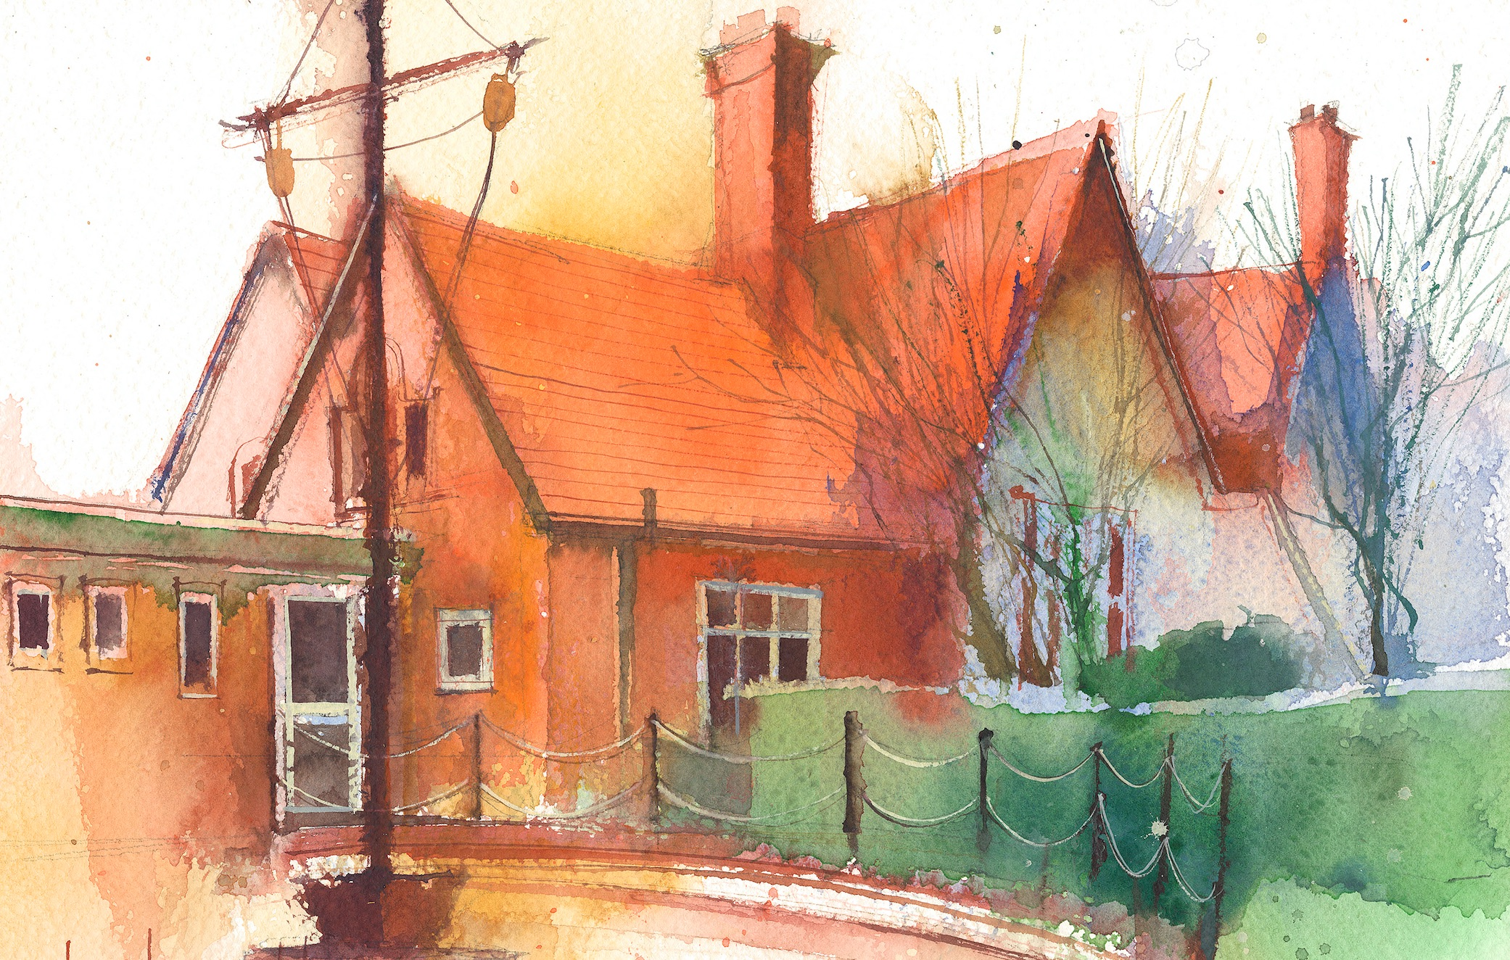

 | Lessons 09:00 – 10:30 |  | Lessons 10:45 – 12:15 |  | Lessons 13:15 – 15:30 (Incorporating 15-minute break) | Additional Tasks
Monday |  |  |  |  |  | Useful Links / Other Recommended Activities  Oak National Academy  https://classroom.thenational.academy/  BBC Bitesize  https://www.bbc.co.uk/bitesize  Purple Mash  https://www.purplemash.com/sch/dawpool#/  Recommended Reading List  See here
Tuesday

Wednesday | Year 5 Grammar  By the end of this lesson your child should be able to:  Spring 2Spag Assessment |  | Year 5 Maths  By the end of this lesson your child should be able to:  Know how to solve balancing  calculations. |  | Year 5 Art – Express Yourself  By the end of this lesson your child should be able to:  To explore how lines and fonts can express ideas.  Year 5 Music – Liverpool Philharmonic – The World in One City: A Musical Journey  Lesson 8 – Homeward Bound!  By the end of this lesson your child should be able to:  · use and understand staff and other musical notations.  · appreciate and understand a wide range of high-quality live and recorded music drawn from different traditions and from great composers and musicians.
Thursday

Friday | Year 5 Reading Comprehension –Non-Fiction-At last the jousts begin! From Castle Diary by Richard Platt and Chris Riddell  By the end of this lesson your child should be able to: Understand and respond to the text accurately.

