**Foundation 2 Weekly Timetable Week Commencing 19.05.25**

**To contact your child’s class teacher, please email** [**schooloffice@dawpool.wirral.sch.uk**](mailto:schooloffice@dawpool.wirral.sch.uk) **or phone 0151 648 3412**

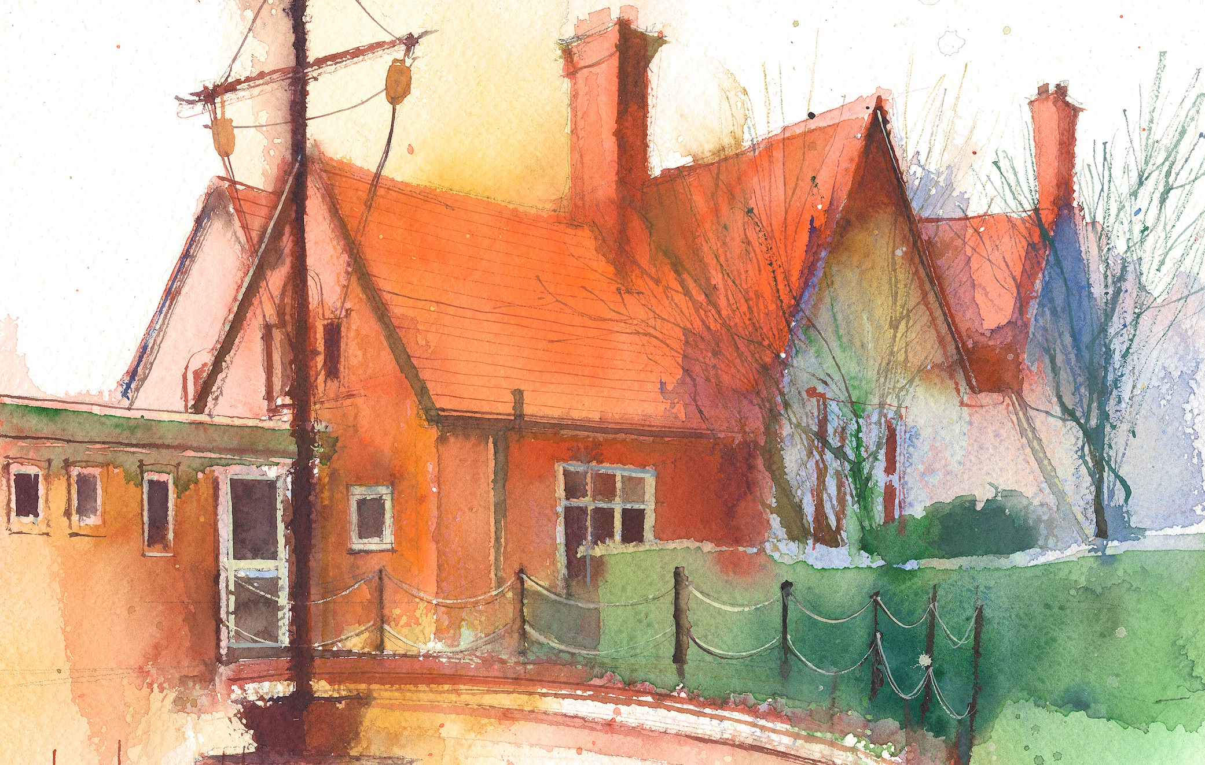

This timetable is available in the event that a Foundation 2 pupil is required to self-isolate at home, but the cohort remains open to other pupils.

Please visit the Foundation 2 **Remote Learning Page** on the school website to access any downloadable resources and activity sheets.

|  |  |  |  |  |  |
| --- | --- | --- | --- | --- | --- |
|  | **Session 1: 09:00-10:30** |  | **Session 2: ­­­­ 10:50 – 12:00** |  | **Session 3: 13:15 – 15:25** |
| **Monday** | **Phonics**  **By the end of this lesson your child should be able to:**  Recognise and say the digraph er  (Week 29)  **We recommend the following resources and activities to achieve this objective:**  Blending practice.  Children will complete activities in their individual rocket phonics workbooks. | **Maths**  **Starter:** Sing the Big Number song. Wave one hand for 5s and two hands for 10s  **Teaching:**  Play a matching pairs game. Explain that two the same is a double.  Spread the cards out on the table.  Children take it in turns to turn over two cards and see if they match.  When a pair is found say ‘double’ as a way of noting that it is two the same. **What do you notice is the same about these two cards?**  At the end of the game place all the doubles next to each other.  **Can you put your cards in pairs that look the same?** | **Topic**  During the afternoons we will undertake activities linked to all areas of the Early Years Curriculum;  **Prime Areas**; Communication and Language;  Personal, Social and Emotional Development;  Physical Development.  **Specific Areas**; Literacy, Maths, Understanding the World and Expressive Arts and Design.  Afternoon sessions will also include RE, HeartSmart and Forest Schools.  Our current RE topic is ‘Special Times’. Planning for this can be found on the website.  Activities will be linked to our class topic which is ‘Where in the World’. We aim to use children’s books as a hook for learning to help us find out more about the world around us. Throughout the year we will select books that enable us to cover all requirements of the Early Years Curriculum.  We will talk about where the book is set and find out where this country is on a map. We will then use the theme of the book as a way of guiding our planning.  **PLEASE NOTE**  The very nature of the EYFS curriculum enables us to go with the interests of the children. The activities we plan are for a guide only.  Staff can use and adapt activities or add additional activities and not cover others. It is all dependent on how and where the children’s interests take us.  Activities are designed to cover several weeks, if needed.  A copy of the current topic plan is available to view on the class website page. |
| **Tuesday** | **Phonics**  **By the end of this lesson your child should be able to:**  Recognise and write the digraph ‘er’  **We recommend the following resources and activities to achieve this objective:**  Blending practice.  Children will complete activities in their individual rocket phonics workbooks. | **Maths**  **Starter:** Together count to 20. Forwards and backwards.  **Teaching:**  Roll a dice and see what number appears.  I will then bring out another dice and place it on the table to show a double.  **What can you tell me about the spots on the dice?**  **Do they show the same number of spots?**  Explain that when the dice shows the same number it is a double.  **What does double mean?**  Encourage the children to work in pairs (double). One of them will roll the dice and can the other one show the same number on their dice?  **If I had a 4 and a 2 would that be a double?**  **If this dice shows 3 spots, how many spots do I need to make a double?**  Can the children roll the dice and see if they get a double of their own?  If this number ends two, ‘splat’ it by circling it and saying ‘splat!’ Continue finding all the even numbers using the poster.  Pause during this activity **What do we notice about the even numbers? Can you predict which number is next?** Continue with numbers ending in 4, 6, 8, 10  **What do you notice about the odd numbers on the 100 square? Can you predict which numbers will be odd?** |
| **Wednesday** | **Phonics**  **By the end of this lesson your child should be able to:**  Consolidate learning of digraphs ‘ar, or’  **We recommend the following resources and activities to achieve this objective:**  Segmenting practice.  Children will complete activities in their individual rocket phonics workbooks. | **Maths**  **Starter:** Together count to 100 in tens.  **Teaching:**  Show the children a picture of a ladybird. It has a matching number of spots on each side.  Show a ladybird with 3 counters on it. Can they make a double?  **How many spots will you need to make a double?**  Repeat to find as many doubles as you can.  **How do you know when it is a double?**  Look at a ladybird with 3 spots on each side.  **How many spots does this ladybird have altogether?**  **How can we find out?**  **What is double 4? How can we find out?** |
| **Thursday** | **Phonics**  **By the end of this lesson your child should be able to:**  Consolidate learning of digraphs ‘ur, ow’  **We recommend the following resources and activities to achieve this objective:**  Blending practice  Children will complete activities in their individual rocket phonics workbooks. | **Maths**  **Starter:** Together count to 20.  **Teaching:**  Watch Numberblocks Series 2: ‘Double Trouble’  At the start 1 isn’t allowed to enter the cave unless he is a double. **What does he need to do to become a double?**  **How many would we have altogether if it was double 1?**  Stop the episode at regular intervals to discuss the doubles all the way up to 8 |
| **Friday** | **Phonics**  By the end of this lesson your child should be able to:  To learn to read the Common Exception words ‘out, like’  We recommend the following resources and activities to achieve this objective:  Segmenting practice  Children will complete activities in their individual rocket phonics workbooks. | **Maths**  Butterfly Art - Make three butterfly shapes.  On one butterfly can you put one spot/swirl/star/sticker etc. on one side.  Now you need to double up. Can you place the same number of objects o the other side. How many altogether e.g. 1+1=2  Your butterfly started with only one decoration. Now you have doubled up it has 2.  On the next butterfly you can add 2 decorations on one side. 2+2=4  On the final butterfly you can add 4 decorations 4+4=8 |