**Year 4 Weekly Timetable Week Commencing 19.05.25**

**To contact your child’s class teacher, please email** [**schooloffice@dawpool.wirral.sch.uk**](mailto:schooloffice@dawpool.wirral.sch.uk) **or phone 0151 648 3412**

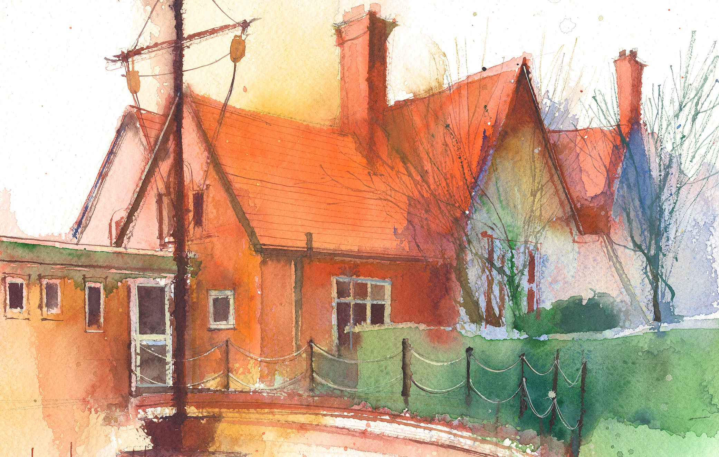

|  |  |  |  |  |  |  |
| --- | --- | --- | --- | --- | --- | --- |
|  | **Lessons 09:00 – 10:30** |  | **Lessons­­­­ 10:45 – 12:15** |  | **Lessons 13:15 – 15:30 (Incorporating 15-minute break)** | **Additional Tasks** |
| **Monday** |  |  |  | Useful Links / Other Recommended Activities  **Oak National Academy**  <https://classroom.thenational.academy/>  **BBC Bitesize**  <https://www.bbc.co.uk/bitesize>  **Purple Mash**  <https://www.purplemash.com/sch/dawpool#/>  **Recommended Reading List**  [See here](https://www.dawpool.wirral.sch.uk/website/recommended_reading_lists/577821) |
| **Tuesday** |  |  |  |
| **Wednesday** |  |  |  |
| **Thursday** | **Year 4 English Reading Comprehension**  By the end of this lesson your child should be able to:  **Understand and respond to the text and answer questions about the story.** | **Year 4 Maths**  By the end of this lesson your child should be able to:  **Know how to interpret charts. Know how to solve comparison, sum and difference problems with data.** | **Year 4 Science - Sound**  By the end of this lesson your child should be able to:  **Be able to find patterns between the pitch of a sound and features of the object that produced it.**  **Sound Assessment** |
| **Friday** | **Year 4 ICT – Mr G Animation.**  By the end of this lesson your child should be able to:  **Use animation programs to create simple animations.** | **Year 4 English**  By the end of this lesson your child should be able to:  **Make sentences more interesting by using adverb clauses.**  **Year 4 Maths**  By the end of this lesson your child should be able to:  **Know how to interpret line graphs.** | **Year 4 RE Unit 4:6Prayer**  By the end of this lesson your child should be able to:  **Discuss and think about.  What is prayer? How do people pray? When do people pray? Why do people pray? Where do people pray**  **What can we learn about prayer from Jesus?**  **In pairs, children use the following Bible passages to find out the answer to that question.**  **Matthew 19:13, Matthew 26:36, Mark 1:35, Luke 5:16, Luke 6:12, Luke 9:28, Luke 22:39, John 17:19-21.**  **After their detective work children feed back to the whole class** *but****record individually.*****I think ……………Jesus teaches…………Jesus shows………….** |