Year 1 Weekly Timetable Week Commencing 24.11.25
To contact your child’s class teacher, please email schooloffice@dawpool.wirral.sch.uk or phone 0151 648 3412
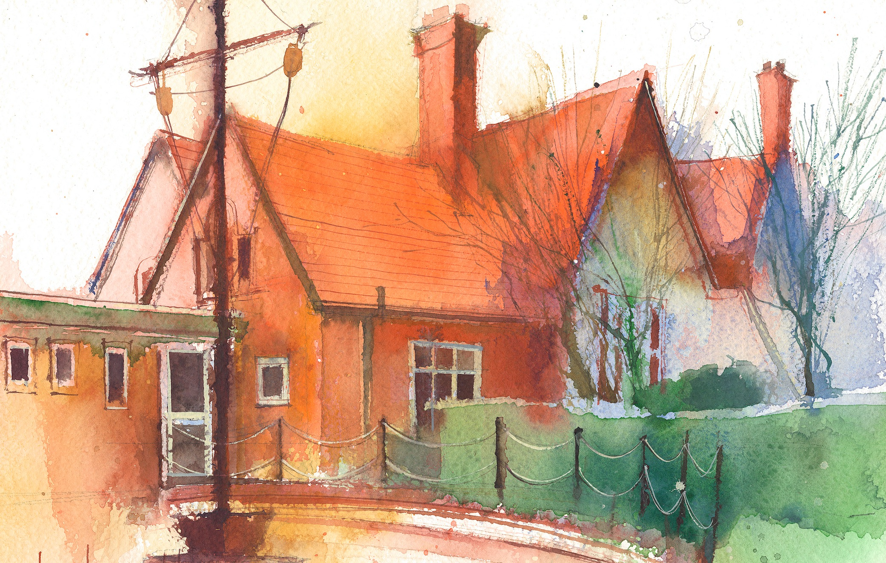

 | Lessons 09:00 – 10:30 |  |  | Lessons 10:45 – 12:15 |  | Lessons 13:15 – 15:30 (Incorporating 15-minute break) | Additional Tasks
Thursday | Phonics: ur as ir (segmenting practise)  Cracking Comprehension |  |  | Maths: To know how to find all number bonds within 10.  ERIC/ GR |  | Fin5  RE (Why do many people give and receive gifts at Christmas?): How do gifts make us feel?
Friday | Phonics: Tricky words: asked, could  Spag | Celebration Assembly |  | Maths: To know how to find number bonds to 10.  ERIC/ GR |  | Fin5  PE: The focus of the learning is for pupils to explore hitting (pushing) a ball using a racket accurately.  Pupils will begin to understand why we need to aim at a target when hitting (pushing) the ball.  Golden Time: Time to play with special toys!

