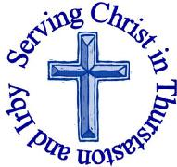
The Churches of
St Bartholomew and St Chad
Thurstaston and Irby
AUGUST 2018

Welcome to Church today.
We hope that you enjoy the service and gain a sense of God’s presence with us.

Children are Welcome at our Services
In St Chad’s, we have activity bags available and there is also a box of toys and cushions in the foyer, in case you feel your child would be happier playing there.
In St Bartholomew’s, there are some colouring sheets and toys at the back of church.
Children from age 2½ can attend Junior Church (term time) at St Chad’s

Services in August
Sunday 5th August – Trinity 10
8.00am Holy Communion St Bartholomew’s
9.30am Morning Worship St Chad’s
11.15am Holy Communion St Bartholomew’s

Sunday 12th August – Trinity 11
ChurchOffice:
Mrs K Butler,
St Chad’s Church, Roslin Road, Irby, CH61 3UH
Open Tuesday, Wednesday, Thursday, 9.30am-12.30pm
(term time)
Tel 648 8169.
Website: www.thurstaston.org.uk E-Mail: office@thurstaston.org.uk

Revd Jane Turner 648 1816 (Day off Tuesday). E-Mail: rector@thurstaston.org.uk

8.00am Holy Communion St Bartholomew’s
9.30am Holy Communion St Chad’s
11.15am Morning Worship St Bartholomew’s

Sunday 19th August – Trinity 12
8.00am Holy Communion St Bartholomew’s
9.30am Morning Worship St. Chad’s
11.15am Holy Communion St Bartholomew’s

Sunday 26th August – Trinity 13
8.00am Holy Communion St Bartholomew’s
9.30am Holy Communion St Chad’s
11.15am Holy Communion St Bartholomew’s
3.00 pm Baptism St Bartholomew’s

Wednesdays 1st, 8th, 15th, 22nd, 29th (Mid-week service)
10.15am Holy Communion St Chad’s

Sunday 2nd September – Trinity 14
8.00am Holy Communion St Bartholomew’s
9.30am Morning Worship St Chad’s
11.15am Holy Communion St Bartholomew’s
FOR OUR PRAYERS THIS MONTH

For the World: Please pray for peace around the World.
For the sick: Please continue to pray for those who are sick or in hospital.
For the parish: Please pray for the parents and godparents of Robert Walton and Olivia Armstrong who are being baptised at St Bartholomew’s on Sunday26th August:
Please pray for the safety of those travelling through the holiday period and for children to enjoy freedom but to be aware of the need to stay safe.

Notices and Announcement
Parish Walk – Saturday 18th August –please see details on the reverse.

St Beartholomew’s Day on Saturday 25th August, 2pm-4pm. Bring a teddy, make a parachute and enjoy watching your bear parachute from the tower of St Bartholomew’s. Bring your friends, children, grandchildren. Donations of cakes (on the day) and children’s raffle prizes most welcome. If anyone can help with this event can you please speak to Julie DeBoorder

Men’s Breakfast on Saturday 8th September, 8.45am-9.45am at Aroma Café Irby.

Open House at the Rectory: Revd Jane will be at home on the following days and would like to invite anyone to pop in for a drink and a biscuit (maybe even a piece of cake if you’re lucky!)
Wed 1st August 7-9pm
Thurs 9th August 10am-12 noon
Wed 15th August 7-9pm
Wed 22nd August 7-9pm
For chair and refreshment purposes it would help to know how many people will come, if you could sign on the list at the back of church that would be really helpful. But you are welcome to come even if you don’t sign on the list! .

EMU: The next meeting will be on Wednesday 19th September, 8pm St Chad’s, we have invited Naomi to come along to talk about the Besom furniture project

Harvest Supper at St Chad’s – Friday 5th October 6-9.30pm. Please arrive for 6pm. Food, Scouse followed by Apple crumble and custard (provided by “Green Catering”) will be served at 6.30pm. Special diets (eg vegetarian, gluten free) to be notified in advance. Please bring your own drinks and glasses. During this part of the evening there will be a table quiz to raise money for Christian Aid and a raffle for Church funds. The second part of the evening will be dancing led by the “Heswall and West Kirby Folk Dance Group” Ticket price £11 (Children aged 4-11 £6.00, under 4 free). The wonderful team of people who have organised and run our Harvest Supper for the past few years are unavailable this year, so any volunteers to help on the day (with setting up tables in the afternoon, clearing tables away in the middle to make space for dancing, running the raffle, co-ordinating the table quiz, which is provided by Christian Aid, washing up etc) would be MUCH appreciated. Please speak to Revd Jane if you can help. Tickets are available to purchase at Sunday services, or via the parish office. Tickets MUST be purchased by Sunday 30th September so final numbers can be passed to the catering company.

OT Live Saturday 27th October 2018 10am – 4.30pm at St Chad’s this one day course will enable you to understand the story of the Old Testament and how it all links together. Tickets are £14 per person for a life changing day, available from
https://www.bible.org.uk/wtb_event_tickets.php (please bring a packed lunch). Everyone receives a full colour workbook and free re-admission for life. 11-16 year olds can attend for free with a paying adult

Date for your Diary – Christmas Fair will be on Saturday 1st December. If there are any volunteers willing to help please speak to Julie DeBoorder

Parish Walk - Sat 18th August
All Timings (apart from start!) are approximate
Approximately 6-7 miles (not measured using any technical devices!)

Can’t do all day or can’t walk far: then come to whatever parts of the day you can manage - Lunch, Pause for Thought at St Bartholomew’s, just the morning (approx 9.00-11.30) or afternoon (approx 12.30-3.00)

8.45am Meet at St Chad’s

9.00am Set off
(1)Turn left out of the car park. At the top of Roslin Rd, turn right, walk through the shops, crossing at the pedestrian lights. At the end of the road turn left. Turn left into Woodlands Rd. At the bottom of the road turn left onto the footpath across two fields (there may be cattle in these fields). At the far side turn right through kissing gate, down steps and over stream. Turn left and follow footpath through Harrock Wood until you reach Thingwall Rd. Cross over, turn right and then left to the entrance of Limbo Lane. (2)
9.20-9.30am Pause for Thought - Health Care
Follow Limbo Lane straight on until you come out at Arrowe Brook Lane. Turn left and proceed in single file along the grass verge (for about 5 minutes) —TAKE CARE. At the roundabout turn left into Mill Hill Road and cross over onto the pavement. Turn left into Sandy Lane North (3)
10.05-10.15am Sandy Lane North - Wait while everyone catches up
Follow the lane as it bends left and then right. As you run out of lane (“Hazledene” on your left), proceed down the footpath (narrow and nettles etc.). At the bottom, cross the bridge and head up the hill ahead of you. Follow the wall on your right. At the far end, continue in a straight line through the woods to reach the corner of Royden Park main field. Follow the wall to the far corner of the field. Turn left up the main path and follow this in a straight line, go through the kissing gate and past Benty Farm. Then take the fork in the path to the right which will bring you to the top of School Lane. (4)
10.50-11.00am Pause for thought - Education
Follow the path along behind Dawpool school (or go up and over the hill) to reach Telegraph Rd. Turn left and walk to the Cottage Loaf Roundabout. If you just want to walk in the morning you could return to St Chad’s from here. Turn right down Station Road taking care as there is no pavement. Follow this road all the way down to the Country Park. (5)
11.45 -12.45pm Picnic Lunch (or visit the Café)
If you just want to walk in the afternoon, you could join us during lunch. Turn onto the Wirral Way (Heswall direction) and follow it under the Dungeon Bridge and then turn left on the footpath signed to the Dungeon. Follow this path (narrow and brambly in places) slightly uphill to the Dungeon (waiting in the opening before crossing the bridge over the stream) (6)
1.15-1.25 Pause for Thought - Farming and Agriculture
Carry on up the steep hill, turning right following the stream, until you reach a T junction in the paths. Turn left and follow this path to St Bartholomew’s (7) If you joined us at lunch, you will now need to return down Station Road to you car.
2.00-2.15pm Pause for Thought at St Bartholomew’s
On leaving Church head up Church Lane (past Church Farm) to reach Telegraph Rd. Turn left to the roundabout. Turn right onto Thurstaston Rd. Turn almost immediately right onto footpath to Irby. Follow this to Dawlish Rd. Turn right and onto footpath which heads left across field to bring you out on Irby Rd. Return to St Chad’s
3.00pm Arrive back at St Chad’s
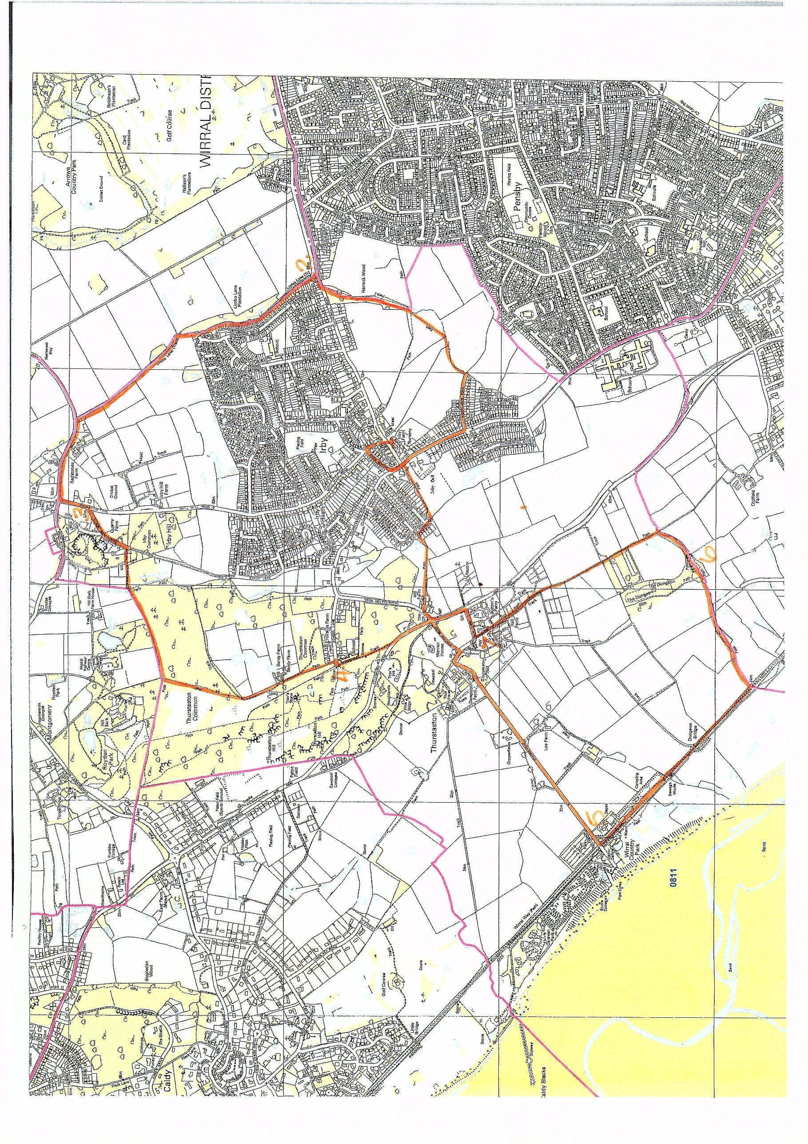
Parish Walk Map - Sat 18th August
Pink Line = Parish Boundary, Orange Line = Walk Route
Please don’t forget to wear
appropriate clothing for
the weather conditions on the day.

Please bring enough water and snacks
to keep you sustained for the walk.

Hazards to be aware of:-
See Blue text in walk description.
Take care crossing roads.
Pause for thought stops
Opportunity to
• pray for a few moments,
• dig in rucksack for a drink or a snack
• add or remove items of clothing
EVERYONE WELCOME
Families - some sections not suitable for prams
Dogs - some sections will need to be on lead

