Foundation 1 -phase 1 phonics
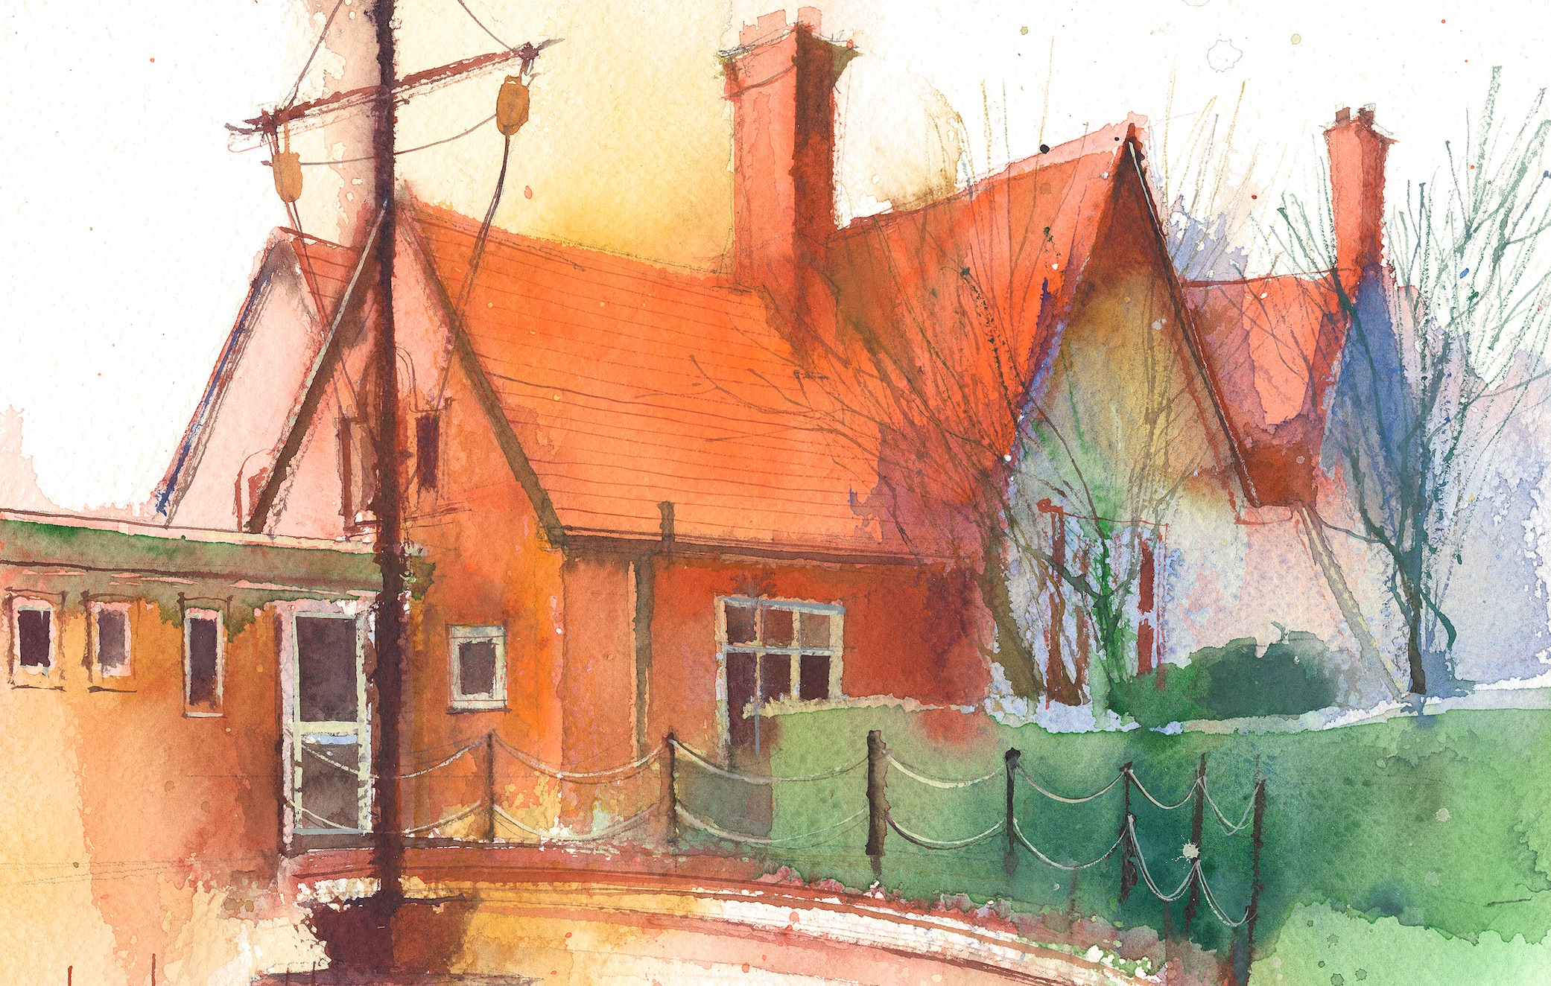

Phase 1: Aspect 1: General Sound Discrimination – Environmental Sounds
Main Purpose: To develop children’s listening skills and awareness of sounds in the environment
Revisit/ Review | Revise sitting skills and explain that we are going to do some investigation in to sounds. What sense/part of our body do we need to use?  Learning cards – good sitting, good looking, good listening, brain boxes on. | Revise sitting and listening skills.  Learning cards – good sitting, good looking, good listening, brain boxes on. | Revise sitting and listening skills.  Learning cards – good sitting, good looking, good listening, brain boxes on. | Revise sitting and listening skills.  Learning cards – good sitting, good looking, good listening, brain boxes on. | Revise sitting and listening skills.  Learning cards – good sitting, good looking, good listening, brain boxes on.
Teach | Rhyming Books  Share a book that has a familiar repeating/rhyming pattern (The Gingerbread Man). | Rhyming soup  Using a bowl and spoon say the rhyming soup song and introduce objects/picture cards that rhyme. Place objects/pictures in the bowl, stir the soup and sing the rhyme. | Songs and rhymes  Sing Hickory, Dickory, Dock, and encourage children to join in. Substitute some of the rhyming words with new rhyming words. Can they hear and say the new rhyming words? | Rhyming Puppets  Give silly names to 2 puppets (Fizzy, Wizzy, Lizzy and Hob Tob).  Talk to the puppets and miss out the silly words or rhyming words. Encourage children to join in saying the silly words. | Odd one out  Select three objects or pictures from a bag (2 must rhyme cat and bat). Say the name of the objects/cards and ask children to find the one that does not rhyme.
Practise | Repeat the book and children practise the repeating words. | Repeat – encouraging children to sing the rhyme. | Repeat with other rhymes. | Repeat activity. | Repeat until children are secure with all objects/cards in the bag.

